Justin

Justin-392904@2freemail.com

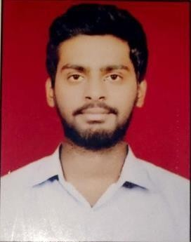
Worked as a Personal Banker at HDB Financial Services(HDFC Bank). At HDB handled a portfolio of 1300 HNI clients where had to build relationship with all of them and need to generate leads and required sales according to clients requirement, also promote new products and give time to time updates on services so that clients can stick with the bank and bank can earn profit with that.

EDUCATION
MBA (Marketing) – GGSIPU (2015- 2017)

BBA Jamia Hamdard University(2012-2015)

SKILLS & EXPERTISE
- Good Communication
- Coordination amount different Verticals.
- Process analysis & Improvement
- Good patience
- Negotiation
- Formulating effective strategies.
- Team Management

PROFESSIONAL EXPERIENCE

HDB FINANCIAL SERVICES | October17- January19
Personal Banker

Sales and Service management:
- Filtering the clients for right product and negotiating the terms on which they would be ready to be a part of the product and services.
- Developed the long-term relationship so that I can build rapport with clients.
- Ensure time to time sales happening so that targets are been achieved on time.
- Regular interactions with clients for the timely resolution of any complaints.
- Creating an awareness, where the product hasn’t reached yet and making it ready for future.

LANGUAGES KNOWN

- English
- Malayalam
- Hindi

PERSONAL DETAILS
- Nationality : Indian
- DOB : 28th April 1994

Other Roles and responsibilities
  - Conducted The Management Fest for the college for the year 2016-17 as Management Coordinator
  - Conducted survey in JCB.

ACHIEVEMENTS
  - Got medal and certificate in annual sports meet at school level.
  - Got Oscar for achieving Life insurance business in organization.
  - Qualified for medals gift etc for achieving targets
  - Organized various events at College, Church and Company level, managing a crowd strength of 400 plus.

