PHILIP Philip-392905@2freemail.com

CAREER OBJECTIVE

Obtain a responsible and challenging position within your company learn new technologies and skills while utilizing my previous experience beyond my abilities currently, and also to build a strong relationship and client; and exceed expectations to excel within the company

WORK EXPERIENCE

Total 9 years of experience in maintenance and construction and automotive industry

- Ejadah Asset Management Group working as an Technician & Office staff at
EJADAH ASSET MANAGEMENT GROP (10-05-2016 till now)
CONTACT INFORMATION

Address Dubai - UAE

- Peral GTL Qatar ( Compass Qatar )
June 2011 to december 2014 : compass and group PLC/ESS with Qater shell GTL Ltd
Role : Low and High Voltage Technician & Office staff

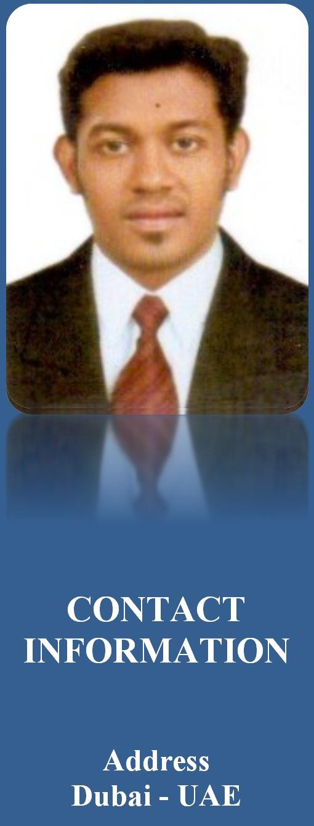
- Electrical dealers and contractors ( Light House ) Electrical Contractors and Engineers , Kottayam - Kerala 2008 To 2011

RESPONSIBILITIES

- Assemble,install,test and maintain Electrical or ELV wiring, equipment,
appliances, apparatus, and fixtures, using hand tools and power tools.
- Connect wires to circuit breakers, transformers, or other components.
- Construct and fabricate parts, using hand tools and specifications.
- Diagnose malfunctioning systems, apparatus, and components, using test equipment and hand tools, to locate the cause of a
breakdown and correct problem.
- Fasten small metal or plastic boxes to walls to house electrical switches or outlets.
- Inspect electrical systems, equipment, and components to identify hazards, defects, and the need for adjustment or repair, and
to ensure compliance with codes.
- Install ground leads and connect power cables to equipment, such as motors.
- Place conduit (pipes or tubing) inside designated partitions, walls, or other concealed areas, and pull insulated wires or cables
through the conduit to complete circuits between boxes.
- Plan layout and installation of electrical wiring, equipment and fixtures, based on job specifications and local codes.
- Repair or replace wiring, equipment, and fixtures, using hand tools and power tools.
- Prepare sketches or follow blueprints to determine the location of wiring and equipment and to ensure conformance to building
and safety codes.
- Test electrical systems and continuity of circuits in electrical wiring, equipment, and fixtures, using testing devises such as ohm
meters, voltmeters, and oscilloscopes, to ensure compatibility and safety of system.

CONTACT INFORMATION

Email
philips-392905@2freemail.com

  - Direct and train workers to install, maintain, or repair electrical wiring, equipment, and fixtures.
  - Perform business management duties such as maintaining records and files, preparing reports and ordering supplies and
equipment.
  - Perform physically demanding tasks, such as digging trenches to lay conduit and moving and lifting heavy objects.
  - Provide assistance during emergencies by operating floodlights and generators, placing flares, and driving needed vehicles.
  - Provide preliminary sketches and cost estimates for materials and services.

EDUCATION

  - B.Com Degree
  - Electrical Diploma
  - NCVT
  - KGCE
  - Higher Secondary ( +2 )
  - SSLC

PROFESSIONAL CERTIFICATE

  - Diploma in Electrical Engineering - KGCE
  - Graduate Diploma in Electrical Engineering - NCVT
  - Certificate for Electrician from ITES Engineering and Vocational Exam Board, Mumbai.

TRAINING AND COURSES ATTENDED

Working at Height | Confined Space Entry
Heat Stress Awareness | LOTO
Manual Handling | Electrical Safety Rules

KEY TECHNICAL SKILLS

Electrical Safety Rules | Total Safety task Instruction | Handling of electrical

PERSONAL DETAILS

Date of Birth : 31-05-1986
Age 32
Nationality : Indian
Marital Status : Married
Language : English , Hindi , Malayalam & Tamil
CONTACT INFORMATION

Address Dubai - UAE

Phone
+971-553923064
+971-559751049

Email
CONTACT INFORMATION

Address Dubai - UAE

Phone
+971-553923064
+971-559751049

Email

