DEEPAK

deepak-392907@2freemail.com

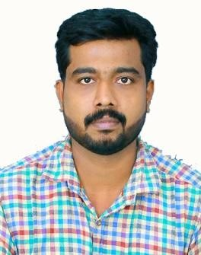Professional Summary
Highly enthusiastic professional as HYGIENE OFFICER/QUALITY CONTROLLER with 5year experience in Food industry with aim to grow and contribute my Skill, Knowledge and experience in the field of Health, Hygiene and Safety, Food quality control. To establish myself in the field of science and technology by developing various skills and talents to achieve an ultimate success.

Professional Experience
- 5 experience as a HYGIENE OFFICER in KMML
- Receive and check materials for conformity to established standards while remaining within the limitations provided by the supervisor.
- Inspect each received component one by one to ensure that it complies with set standards.
- Assist in maintaining food safety programs for the site.
- Superior familiarity with all biological and physical food related hazards.
- Conduct regular checks, lab analysis related for raw material, packaging material and finished good that are produced in the site as well as co- packers.
- Ensure that all products are analyzed and released as per the company standards and mandatory requirements.
- Strong knowledge and understanding of basic Quality control and Quality assurance programs and concepts.
- Monitor recording of lot numbers to ensure no expired ingredients are being used. Ensure proper rework documentation a completed.
- Perform both visual and physical check on process and provide adjustments suggestion to workers.
- Solid understanding of Qualitative, Quantitative and microbiological aspects of food, pest control programs and food regulations.
- Exceptional proficiency in all poultry and meat handling rules and procedures.
- Strong ability to adhere to milk and dairy production and processing rules.
- Outstanding skills in detecting food product impurities.
- High knowledge of seafood and frozen food inspection regulations and procedures.
- Communicate with vendors and suppliers to provide them with feedback on nonconformity to ensure that the next batch is of good quality.

Certification
- Advanced level 3 Award in HACCP for FOOD CATERING
- Advanced level 4 Award in Advance Food Safety.
Education
- Master of Science in Analytical chemistry (Kerala University)
- Bachelor of Science in Chemistry (Kerala University) Trainings and Project
Undergone project training in drug Standardization unit, Govt.Ayurveda College, Thiruvananthapuram on the topic “phytochemical investigation of Myristicafragrans and Zingberofficinale and effect of dilution on jeerakaristam”

Personal Details

Nationality : Indian
Age & Dob : May 03 1989, 30 yrs. Sex : Male
Marital Status : Single

