CURRICULUM- VITAE
RAHUL 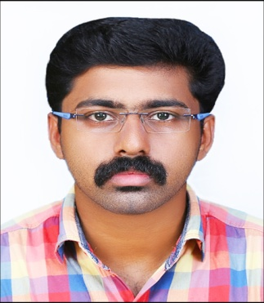
E-mail: rahul-392912@2freemail.com

OBJECTIVE:

TO BE A THOUGHTFULLY COMMITTED & CO-OPERATIVE TEAM PLAYER. INTEND TO BUILD A CARRIER IN A LEADING CORPORATE AND TO PURSUE THE MOST VERSATILE OF MY TALENTS.
PROFESSIONAL EXPERIENCE:

- NOW WOKING AS A BRANCH MANAGER
- WORKED AS A BRANCH MANAGER FOR FOUR YEARS ,
- WORKED AS A CASHIER & MARKETIVE EXECUTIVE FOR TWO YEARS ,
- WORKED AS A CASHIER IN ELECTRICAL SHOP FOR 6 MONTHS ,
RESPONSIBILITIES:

- TO MANAGE THE OFFICE AND FINANCIAL MATTERS.
- TO DEAL THE MONEY TRANSFER,CURRENCY CHANGING,ETC.
- TO ENTER THE DAILY DATA INTO SYSTEMS.
- TO APROVE THE GOLD LOANS AND KUDUMBHASREE LOANS.
- TO APROVE THE LOANS FOR CUSTOMERS.
- TO PREPARE THE DAILY ATTENDANCE IN THE COMPANY SOFTWARE.
- TO ARRANGING WEEKLY BRANCH MEETING.
- TO PREPARE THE DAILY REPORTS AND SEND TO HEAD OFFICE.
- TO CORDINATE THE FIELD STAFFS FOR WORK.
- TO MAKE MAXIMUM COLLECTION FROM CUSTOMERS
- TO COMMUNICATING WITH CUSTOMER.
- TO PREPARE THE INCOME &EXPENDITURE A/C.
- TO CHECK THE DAY TO DAY EXPENSES.
- TO COLLECT THE FILE OF CUSTOMERS FROM FIELD STAFFS.
- TO COLLECT THE DAILY COLLECTIONS FROM FIELD STAFFS.
- TO CHECK AND VERIFY THE DOCUMENTS AND FORWARDING TO H.O.
- TO CORDINATE THE FIELD STAFFS FOR GETTING MAXIMUM FILES.
- TO SEND THE UPDATED DATAS TO HEAD OFFICE.
- TO TAKE PROCEEDURES FOR SANCTION THE LOANS. ETC.,
ACADEMIC BACK GROUND:

- COMPLETED THE B.COM GRADUATION.(LAKSHMI COLLEGE,CHALAKUDY)
- COMPLETED THE PLUS 2 (SARASWATHY VIDYA NIKETHAN HIGHER SECODARY SCHOOL,KODAKARA.)
- COMPLETED THE 10TH STANDARD (SARASWATHY VIDYA NIKETHAN HIGHER SECODARY SCHOOL,KODAKARA.)
TECHNICAL SKILLS:

- TALLY
- KNOWLEDGE IN COMPUTER COURSES, LIKE WINDOWS,EXCEL,POWER POINT,TALLY ETC.,
- DIPLOMA IN INDIAN AND FORIEN ACCOUNTING
PERSONAL DETAILS:
NAME : RAHUL
AGE : 26
DATE OF BIRTH : 15-04-1992.
QUALIFICATION : B.COM
LANGUAGE KNOWN : MALAYALAM,ENGLISH
HOBBIES : READING BOOKS,HEARING SONGS,WATCHING MOVIES,
PLAYING GAMES, ETC.
DECLARATION:

I HEREBY DECLARE THAT ALL THE DETAILS FURNISHED ABOVE ARE TRUE TO THE BEST OF MY KNOWLEDGE.
.PLACE: PARIYARAM
RAHUL

