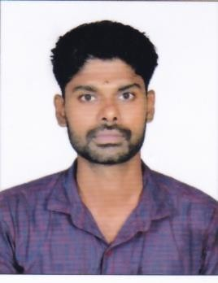
RESUME
JIJO
jijo-392917@2freemail.com

Executive Summary:

Seeking a position where my professional experience and education will allow me to make an immediate contribution as an integral part of a progressive company.

Academic Profile:

B.Com
- Victoria College, Kunnamkulam, Kerala, India
- Co-operation
- Affiliated to Calicut University, April 2014

Higher Secondary

- Commerce
- G H S S, Kochannur ,Thrissur
- Kerala State Board, March 2007

SSLC

Kerala State Board, 2005

IT Skill Set:

- Sound knowledge and understanding of Excel

- Well versed in windows and MS office

- Advanced Diploma in Manual and Computerized Accounting (ADMCA), Certification in Tally

Personal Information:

Date of Birth : 03-06-1990

Sex : Male

Marital Status : Single

Languages Known : English, Malayalam
Nationality : Indian

