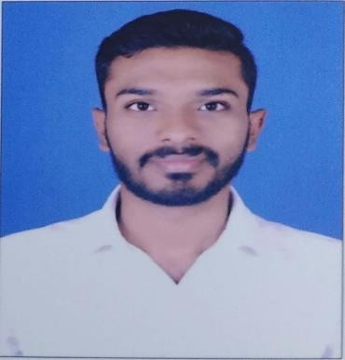To secure a challenging position in a reputable organization to expand my learnings, knowledge, and skills. A highly organized and hard-working individual looking for a responsible position. An enthusiastic individual seeking a mid-level position in any firm where I can use my negotiation and communication skills to achieve the targets.
Binith

binith-392918@2freemail.com
Objective

Academic Qualification

Course | University/ Board | Year
B.Com | Mahatma Gandhi University, Meghalaya | 2016
Higher Secondary | Mumbai University | 2012
Secondary | Mumbai University | 2010

Work Experience

Axis Securities LTD & Quess Corp LTD –For Axis Bank.

I was working as an Executive for Fraud & Dispute Team in Credit Card Operation Post Insurance since 20th April 2017 till 01st July 2019 and the following are my primary Roles and Responsibilities in this position.

Responsibilities
- Handling Debit Card & Credit Card Insurance.
- Finding / Searching Customer Details from Finacle / DCMS for debit card.
- Taking care of Insurance Queries.
- Preparing and Maintaining MIS details.
- Handling customer dispute and fraud queary.
- Mapping of Customer’s Details in System such as CTL for credit card.
- Raising dispute and fraud cases of customer in CCRS system and UIB lodgment.
- Team management.
- Handling Statement and Product Related processes.
- Core MIS pertaining Activities.
- Charges and Cashback processing.
- Complementary cards processing and post issuance activities.

PROFESSIONAL SKILLS
- Good correspondence & Follow Up Skills ★★★★
- Ability to Work Under Pressure ★★★★★
- Ability to achieve target oriented tasks on time ★★★★★
- Strong interpersonal and Willingness to learn ★★★
- Teamwork ★★★★

IT Skills
- Proficient In: MS Office, Internet Savvy.
- Software: Finacle, CCRS, UIB lodgment, Debit card regional system, Credit term Ltd, Mis report, Finacle CRM.

LANGUAGES KNOWN
- English ★★★★★
Excellent- Reading, writing & speaking

- Hindi ★★★★
Basic - Reading, writing & speaking

- Marathi ★★★
Basic - Reading, writing & speaking

- Malayalam ★★★
Basic - Mother Tongue

Personal Details
Date of Birth : 27th June 1994
Gender : Male
Martial Status : Single
Nationality : Indian
Visa Status : Visiting Visa

