PRADEEP
EMAIL: pradeep-392937@2freemail.com
Applied for the post of any Suitable job 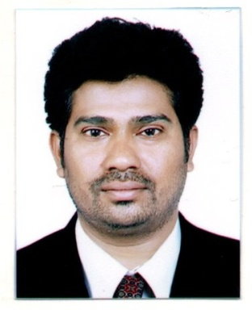

OBJECTIVE:
Seeking a good career and holding a responsible position in the reputed organization and ensure credible performance to work towards exceeding the set goals contributes for the organization.
EDUCTIONAL ATTAINMENT:
- 12th passed (Intermediate : Live sciences)
- Basic computer knowledge, (MS Office, Excel, PowerPoint, etc.,)

WORK EXPERIENCE:
Worked as AR Analyst from 2015 to 2018 in 2018, Hyderabad, INDIA.
Job Profile/Job Activities which are being presently handling:
In medical billing, AR stands for Accounts Receivable. Accounts receivable are the claims that are unpaid by insurance companies or patients. Looking up on all the payments received from the insurance and patients.
- Constantly keep track of both online payments and checks issued.
- Always monitoring weakly reports, monthly reports and verifying the differences.
- Constantly working on payments and reports from major Carriers and possess strong analytical and problem solving skills.
- Responding back to the customer quarries.
- Ensure the AR days meet Industry standards.

PERSONAL DETAILS:
Name : Pradeep
Date of Birth : 07/08/1985
Visa Status : Visit Visa
Validity : 05/10/2019
Nationality : INDIAN
Marital Status : Married
Languages Known : English, Hindi, Telugu.

DECLARATION:
I hereby declare that the particulars furnished above are true to the best of my knowledge and belief.

PRADEEP

