Y U V A R A J
Yuvaraj-392939@2freemail.com
Ajman, U.A.E
C i v i l E n g i n e e r
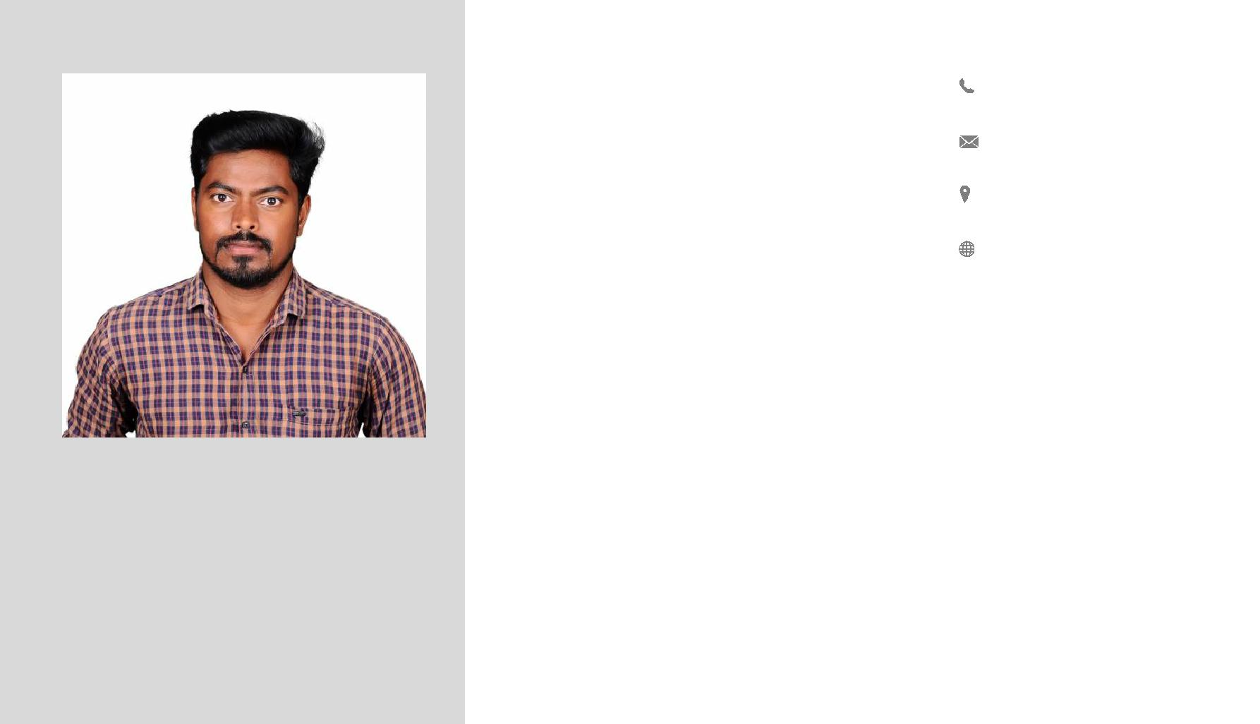

OBJECTIVE

I can prove my technical competence, innovation, creative thinking and Strategic planning as an individual and as a team. I will ensure each work by me will be done within a stipulated time, specified quality and specified cost and also co-ordinate with my entire team

EMPLOYMENT CHRONICLE

Total Civil Engineering Carrier Experience -8 Years

Total U.A.E Experience

- 4 Years + Driving License

VISA STATUS:

VISIT VISA ( Expires on 12/8/2019)

WORK EXPERIENCE

A) Company Name | : | (Feb 2015 to Feb 2017),
Project | : | Residential, Commercial Building and villas,
Designation | : | Civil Engineer with U.A.E Driving License,
Place | : | Ajman City, UAE.
B) Company Name | : | (Feb 2017 to Feb 2019),
Project | : | Residential, Commercial Building and villas,
Designation | : | Civil Engineer with U.A.E Driving License,
Place | : | Ajman City, UAE

Duties and Responsibilities

Preparing Detailed and abstract Estimation for buildings, Apartment, Warehouse and Villas as per UAE by-laws and consultant drawing with specification. Preparing Quotation through BOQ.
Preparing Bank Loan Documents and Agreement.

Preparing and sending SZHP Bills and document through online.

Preparing Stage Running Bill for SZHP, Bank and Cash payment work.

To determine and monitoring the consumption of resource like material, man power and machinery power.
Main and Sub-Contractor periodic bill preparation.

To make the time planning schedule for all our projects.

Arriving quotation from various subcontractor.

Giving site checking to consultant and municipality like setting out of structure, all stage steel with shuttering checking, level and demarcation checking.
Site quality controlling.
C) Company Name | : | (Aug 2011 to Dec 2014)
Project | : | Residential and Commercial building,
Designation | : | Site Engineer,
Place | : | Chennai, Tamil Nadu, INDIA.

SKILLS | SOFTWARE PROFILE | AREA OF INTERESTED
Creativity | ➢ Archi CADD | ➢ Executing sector
 | -(Drafting Software)
Communication |  | ➢ Estimating sector
 | ➢ Auto CADD
Hard work | -(Drafting Software)
Team work
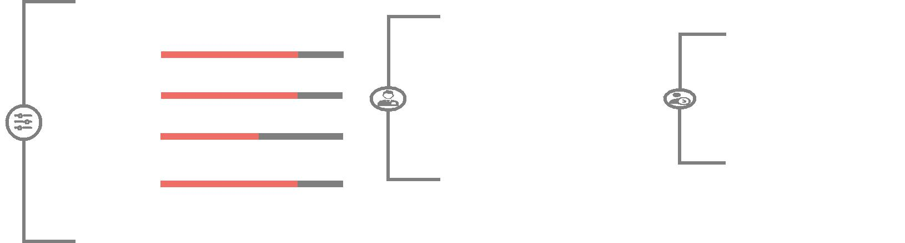

EDUCATIONAL QUALIFICATION

➢ Bachelor of Engineering -2007to2011 (BE-civil) (71.7% First Class)
Lord Venkateshwara Eng. Collage, Affiliated to Anna University Chennai.

➢ H.S.E.,(+2) | (2007) | (73.9%)
Sri RamakrishnaVidyalaya Boys Hr.Sec School, Chengalpet.
➢ S.S.L.C.,(10th) (2005) |  | (86%)
P.T.V.S High School, Thirukkazhukundram..

PERSONAL DETAILS
 | Name |  |  |  | : | YUVARAJ
 | Date of Birth/ Sex |  |  |  | : | 7th April 1990. /Male
 | Marital Status |  |  |  | : | Single
 | Nationality |  |  |  | : | Indian
 | Language Known |  |  |  | : | Tamil, English, Hindi & Telugu (speak)

Declaration

I hereby declare that the above said information is true to the best of my knowledge.

Station :

Yours Truly,

(YUVARAJ)

