Curriculum vitae

NAME: Queenta

Email: queenta-392942@2freemail.com
Nationality: Cameroonian
Visa type: Visit Visa

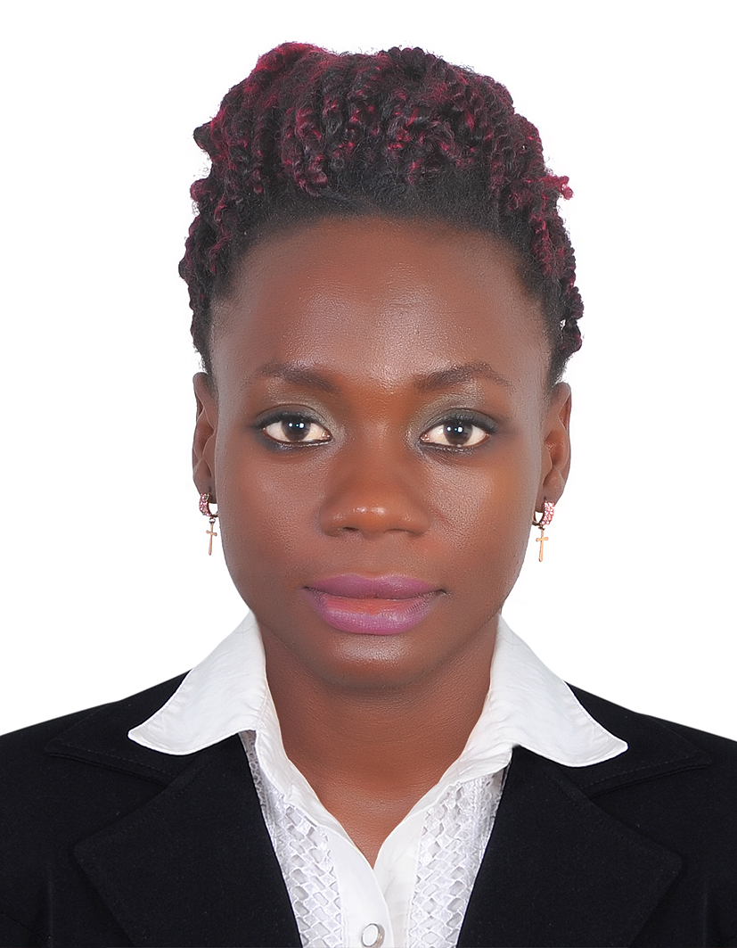
HOUSEKEEPER
A confident and approachable individual who has the commitment, enthusiasm and
energy needed to succeed in a role as a Housekeeping Supervisor. I can develop a
housekeeping team to deliver a high level of service. I have experience of working in a hotel that has over 200 bedrooms, including suites and has a fully equipped
Gym with pool. As a true professional I will always be a 'hands on' part of the
Housekeeping Team. Right now she is looking forward to join your team and to improved in the growth of my career in reputable hotel.

Core competencies
- Ensuring high levels of attention to detail and professionalism.
- Smart in appearance as well as professionally confident, polite and welcoming at all times.
- Have a full command of English.
- Have exceptional customer and service standards.
- Passionate about customer care and offering a first class service to guests.
- Aware of all relevant Security, Health and Safety issues.
- Attention for detail and a passion for continuous personal improvement.
- Possess strong organizational skills with a keen eye for detail.
Special skills
- Profound ability to deal with a variety of people from different cultures
- Record keeping of basic hotel rooms utilities.

MAIN DUTIES THE PARK LANE HOTEL ROOM ATTENDANT 14 JUNE 2015 TO 31 AUG 2015
- Clean and remove garbage in guest room
- Clean bathroom dust table and furniture
- Vacuum floor and corridor
- Replenish bathroom amenity

PROFESSIONAL EXPERIENCE
Room Attendant at Shamrock hotel - Cameroon 2015 - 2017
Duties
- Collecting and removing rubbish from gust room
- Cleaning bathroom hoover guest room dusting table
- Complying with all health and safety regulations at all times
- Reporting any problem to the housekeeping supervisor

EDUCATION QUALIFICATION
Ordinary Level Certificate 2015 - MARTIN LUTHER SECONDARY SCHOOL Kumbat
LANGUAGES: ENGLISH and French

PERSONAL DETAILS
- Date of Birth : April 21, 1997
- Nationality : Cameroonian
- Languages : English and French

References:
- Mr. Ndip Nathan Eyong: Personal Assistant / Document Controller to the General Manager at Standard Fabrication and Engineering Works, Dubai, UAE, Mobile 0552927189, email: nathanndip@yahoo.com
- Miranda Acha: Assistant Teacher, AQUILA School: email: achamira34@gmail.com, Mobile: 0588436386. (Mentor)

