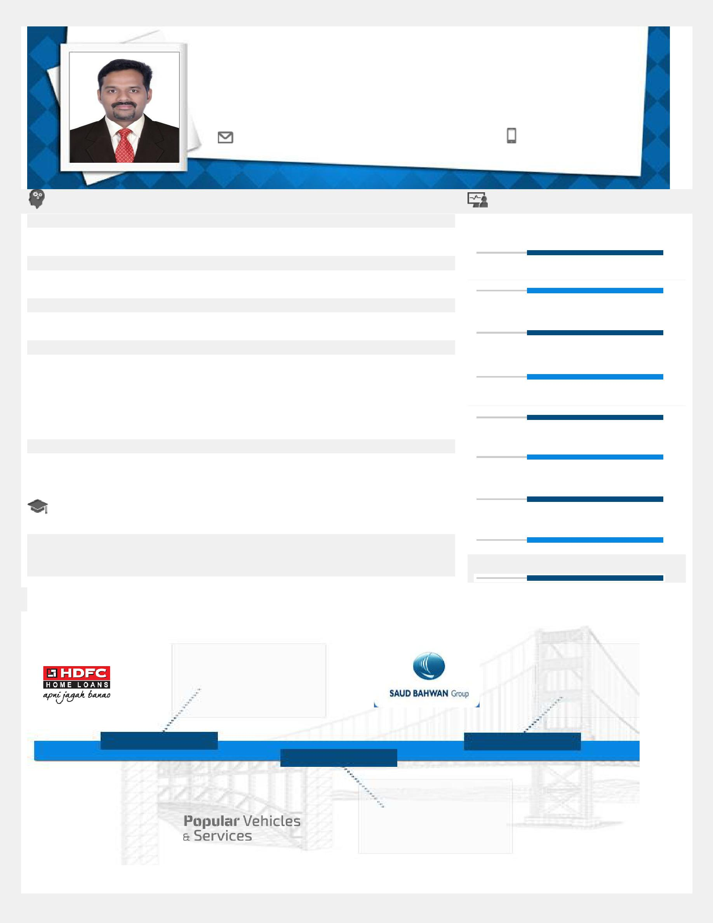
KISHOR

Targeting senior level assignments in Marketing & Sales/ Business
Development with an organization of repute

Kishor-392956@2freemail.com

Profile Summary | Core Competencies

• Strategic sales & marketing specialist offering nearly 15 years of
 | cross-cultural experience in Sales & Marketing with key focus on top line | Strategic Business Planning
• | profitability & revenue expansion
 | Proven success in developing, implementing & executing marketing initiatives, | Sales & Marketing
 | sales forecasting, budgeting and enhancing processes for market development
 | in different segments for better market penetration
• Leveraging skills in designing, implementing and monitoring strategically |  | Key Account Management
 | focused sales plans for creating advantage to both the company & business
 | partners across the career
• Developed and rolled-out winning plans for new product launches, product line |  | Market & Competitive Analysis
 | extensions and product management/marketing initiatives
• Proficiency in keeping track of market trends and competitor moves as well as
 | achieving market share matrices | Sales Promotions & Launches
• | Successfully ranked:
 | o 4th in quarterly superstar contest in Muscat showroom in 2017
 | o 2nd highest performer in Ramadan Sales Muscat showroom in 2016 | Budgeting & Forecasting
• Expertise in developing relationships with key decision-makers in large
 | corporate and enterprises for business development, for suggesting most
 | viable services & cultivating healthy relations with them for repeat business | Customer Relationship Management
 | Education | Revenue Generation
• MBA (Marketing) from Bharathiar University, Coimbatore in 2004
- Post-Graduation Diploma in Advanced Computing (PGDAC) from

 | Amrita Institute of Science & Technology, Kochi in 2002
• |  |  |  | Team Management / Trainings
 | B.Com. from Mahatma Gandhi University, Kochi in 2000

Career Timeline

as Sales
^{Officer} as

Sr. Executive – Sales

May’04-Mar’05 Dec’06-Dec’18

Apr’05– Oct’06

as Sales Executive

Work Experience
Dec’06-Dec’18: Oman

Growth Path:
Dec’06-Dec ’12 as Sales Consultant

Jan'11-Dec’18 as Sr. Executive – Sales

Role:
- Actively developing sales strategies for entire range of Saud Bhawan Distrubition products by identifying opportunity areas in close coordination with Sales and Product Strategy teams
- Managing the sales, service & operations for promoting Toyota Family of premium products like Passenger Cars, 4WD Vehicles, sporty SUVs & Commercial Vehicles
- Planning and implementing marketing activities including sales promotions, brand promotions including displays, sales promotion events, shows, test-drive camps & mega events
- Driving Key Account Business involving sales forecast, planning of process, monitoring all products; motivating sales team to achieve primary /secondary sales targets in institutions & corporate

- Managing:
o Budgeting & spearheading commercial planning, capital sourcing (Marketing investment planning), systems establishment and sales process during Ramadan
o Evaluating of partner performance & process capability; spearheading sales & marketing for target achievement
o Conducting opportunity, market trends analysis on competitor moves to achieve market-share metrics; managing entire product lifecycle from strategic planning to tactical activities

o Identifying areas for growth and creating product-line roadmaps to help drive adoption of the product, conducting research on customer feedback, analysis of key performance indicators, and capturing metrics of the product
- Designing operational/ marketing and distribution strategy in line with the company's strategic intent, meeting annual contribution and volume, formulating national operational/ marketing plan
- Using outlet insights to revamp visibility platforms and deploy category management strategies to increase in market share, sales, footfall/ traffic, gross margin, ROI, and customer satisfaction
- Designing solutions for key operational & client issues that impact revenue and gross profit; liaising with clients and partners to build relationships and increasing business longevity and revenues

Highlights:

- Drove substantial annual net revenue and profitability growth; exceeded team goals through initiatives like: o Building strong client relationships; developing and executing Path to Purchase marketing strategies
o Optimizing all activities based on available analytics to maximize ROI
- Successfully ranked:

o 5th in quarterly Superstar Contest in Muscat showroom in 2013 o 4th in quarterly Superstar Contest in Muscat showroom in 2013 o 2nd in Ramadan Sales in entire Sherquiya region in 2012
Apr’05– Oct’06: Kochi as Sales Executive
Highlights:
- Managed Sales, Service & Operations for promoting Maruti Suzuki family of premium products like Hatchbacks,

Sedans, Vans, SUVs, MUVs
- Delivered product demonstration & arranged test drives for prospective customers; negotiated, closed and

delivered vehicle within TAT
May’04-Mar’05: Kottayam as Sales Officer Highlights:
- Successfully developed business & coordinated with developers & builders; generated MIS reports

- Resolved various legal & technical queries related to processing of Housing Loans; ensured speedy resolution of queries & grievances to maintain 100% customer satisfaction

- Served clients from initial loan process till final disbursement

Personal Details
Date of Birth: 18th May 1979

Languages Known: Arabic, English, Hindi, Tamil & Malayalam

Visa Status: Required
Nationality: Indian

Marital Status: Married

No. of Dependents: 3
Passport (Valid Till 6/3/2029)

Driving License : Oman(Muscat)/India Driving License Holder

