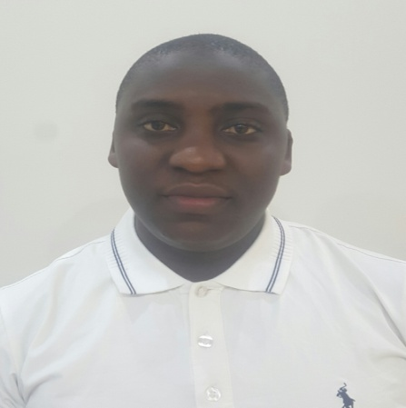

**QUALIFICATION**

**HIGH SCHOOL; Uganda Advanced certificate**

**INSTITUTE: Diploma in electrical engineering**

**CERTIFICATION:**

* + - **SIRA certificate**
    - **Basic life support**
    - **Fire fighting certificate.**
    - **Armed security guard training**

**LANGUAGES:**

* **English**
* **Swahili**

**HASHIM**

[Hashim-392970@2freemail.com](mailto:Hashim-392970@2freemail.com)

**EXPERIENCE**

**Night parking Attendant Dec/2014 to Feb. /2016;**

*Responsibilities*

* Take numbered tags from customers, locate vehicles, and provide customers with instructions for locating vehicles.
* Keep parking areas clean and orderly.
* Greet customers and open their car doors

**Sales man at NSY gametes March /2016 to July 2018;**

*Responsibilities*

* Interacting with customers, offering information about products,
* Maintaining the store area clean and organized, receiving merchandise,
* Displaying fashion items and collecting payments.

**personal info**

NAME : HASHIM

SEX : MALE

DATE OF BIRTH: 10/01/1992

NATIONALITY : UGANDAN

RELIGION : MUSLIM

VISA TYPE : EMPLOYMENT

**EXPELIENCE DUBAI**

**Kitchen 09/2018 to date;**

Responsibilities;

* Operating and maintain cleaning **helper in Intercat company** equipment and tools.
* Responsible for washing dishes, china ware, flatware, cutlery, crockery, kitchen vessels, Sweeping and mopping floors,
* Cleaning and detailing equipment's etc.

**OTHER SKILLS**

Time management, Ability to work under pressure, multiple tasking, computer skills, driving, ability to pay attention to little details, communication skills