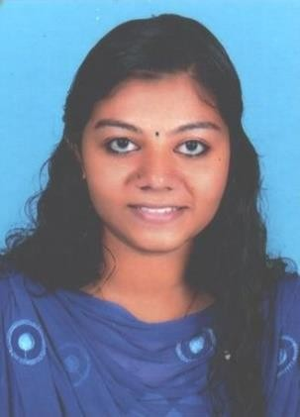
CURRICULUM VITAE

SUMENDU
Sumendu-392993@2freemail.com

CAREER OBJECTIVE
To qualify as Civil Engineer in a well-established engineering company or consultancy which facilitates my professional growth & experience in construction industry.

EMPLOYMENT EXPERIENCE
Company : Cosmic Builders & Contractors, Kerala, India Title : Quantity Surveyor cum office assistant Tenure : December 2018 to June 2019

- Conducting feasibility studies to estimate materials, time and labour costs.
- Valuing completed works and preparing bill accordingly.
- Preparing bar bending schedule prior to the execution of work.
- Preparing, negotiating and analyzing costs for tenders and clients.
- Coordination of work effort.
- Monitor progress of the work as per the schedule agreed.
- Material management and quality control.
- Day to day management of sites, including supervision and monitoring of labours.
- Preparing bill of quantities (BOQ) when required.
- Receiving and processing all invoices, expense form and request forms for payment.
- Organizing and observing the day to day activities of organization.
- Respond to emails, phone calls and other forms of correspondence.
- Pays employees by calculating pay, distributing checks and maintaining records.
- Prepare the cost and value information for monthly account meetings.

Company : SANDH Construction Company, Pvt. Ltd, Kerala, India Title : Civil Engineer Trainee
Tenure : July 2018 to December 2018

- Scheduling the work of the day and ensuring that the projects starts on time and ends within the estimated duration.
- Making Structural Details on Auto CAD.
- Shop drawings.
- Prepare Elevation & Section of building plan.
- Customizing of Auto CAD utility symbols library of civil.
- Prepare drawing list, arrange drawing numbers and keep up to date record.

- Using computer System for easy future reference.
- Preparation of making 2D & 3D views of buildings.
- Preparing as built drawings.
- Preparation of building plan, sections, elevation & detail drawings, door & window details.
- Making dimensions.

EDUCATIONAL QUALIFICATION
- B.Tech in Civil Engineering
Holy Kings College of Engineering and Technology, Kerala, India

XII (CBSE Board)
Fatima Central School, Kerala, India

X (CBSE Board)
- Fatima Central School, Kerala, India

SKILLS AND CERTIFICATIONS
- Self-motivated & Confidential
- Excellent time management skills.
- Proficient computer skills in Quantity Surveying, AutoCAD,Revit Architecture,3DS Max and MS Office.
- Documentations.
- Writing accurate technical reports.
- Excel efficiency.

COMPUTER PROFICIENCY
- AutoCAD 2D
- 3ds Max
- Adobe Photoshop
- V-ray
- M S Office
- Revit Architecture

PERSONAL DETAILS
- Date of birth : 31 March 1996
- Nationality : Indian
- Marital Status : Single
- Visa Status : Visiting visa
- Language known : English, Malayalam (Mother tongue)

