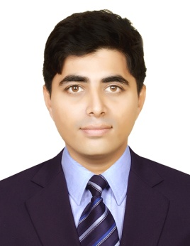
CURRICULAM VITAE

MADIH
Email : madih-393008@2freemail.com

Objective

To apply and integrate Knowledge & skills effectively in a job requirement to enhance work
Performance and contribute to the organization sincerely with integrity and devotion. Make
Sincere efforts to grow along with the company

Strengths

Able to adapt and work well in multicultural environment
Motivated Team Player
Effective communication, Presentation & PC Skills

Career Profile

- Experience in Quality control department with Cooper Standard Automotive Private Limited in Chennai, India.
- Experience as a Graphics Designer with Brand Recall in Chennai, India.
- Presently working as a Field Operation Trainee Engineer in Dubai UAE.

Educational Qualification

- Diploma in Electrical & Electronics Engineering (2013 - 2016)

Vocational Course

- Diploma in Automobile Engineering (2010 - 2011)

Technical Courses

- Hardware & Networking (A+, N+) (2008)
- Mobile Phone Technical Training (2010)

Computer Professional Courses

- Honours Diploma in Computer Application (HDCA) (2008 - 2009)
- Diploma in AutoCAD professional (2007)
- C-TECH in Graphic Design (Photoshop, Illustrator, InDesign) (2017)

Skills

- Worked in Quality Control Dept. as I know measuring dimensions of the Materials using vernier caliper, Thickness of tubes using Micron Meter and find out any defectives of the materials as Visual Inspects.
- As a Graphic Designer would Know making Logos, Brochure, Dangler, Standee, Banners and also web layouts using softwares Adobe Illustrator, Photoshop and InDesign.
- I have learned as a Mobile service technician how to remove IC’s Using Blowers and replacing methods and I would like to troubleshooting any issues in motherboards and firmware flashing Knowledge.
- I have learned as a PC hardware Technician would know troubleshooting any issues in softwares and Hardware replacing whenever it needs. Knowledge about OS installations, Partitions tools and Hardware Assembling.
- Making and reading drawing using AutoCAD software.

Personal Profile

Date of Birth : 30th Dec. 1990

Marital Status : Unmarried

Languages Known : English, Hindi and Tamil

Nationality : Indian

