CURRICULUM VITAE

 |  | ATHUL
 |  | Email ID : athul-393029@2freemail.com
PERSONAL DATA
DATE OF BIRTH |  |  |  |  |  |  | : |  | 02/08/1993
AGE |  |  |  |  |  |  | : |  | 25
SEX |  |  |  |  |  |  | : |  | Male
RELIGION |  |  |  |  |  |  | : |  | Hindu
MARITAL STATUS |  |  |  |  |  |  | : |  | Single
LANGUAGES KNOWN |  |  |  |  |  |  | : |  | Malayalam, English
EDUCATIONAL QUALIFICATION
 |  | S S L C
 |  |  | Plus Two
 |  |  | Diploma in Sound Engineering
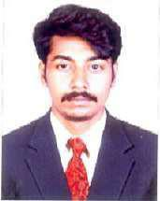
EXPERIENCE

1 Year and 9 Months Experience as Photographer

SKILLS AND INTEREST

Computer Knowledge

Good in oral and written Communication

Photography

VISA DETAILS
TYPE OF VISA |  | : | Visiting

DECLARATION

I hereby solemnly declare that the information furnished above is true to the best of my knowledge and belief.

Place

Date

:

:

ATHUL

