CURRICULUM VITAE
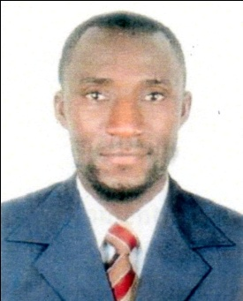
ROGER
Email ID: roger-393032@gulfjobseeker.com
Dubai -U.A.E

CAREER OBJECTIVES:
Security Guard

Looking for a challenging position as a Security Guard at your company utilizing a vigilant eye and extensive experience in security services to ensure the safety of people and property.

SECURITYRELATEDSKILLS:

- Adept at handling emergency situations effectively; medical emergencies, accidents and other threats
- Hands-on experience in managing security systems in order to prevent theft,violence and vandalism
- Well-versed in using different alarms for security purposes
- Practical approach of observing all activities at premises and reporting any suspicious circumstances

PROFESSIONAL EXPERIENCE:

Position: Security Guard
Company: in Cameroon
Duration: 2-years
Two years work experience in UAE

DUTIES & RESPONSIBILITIES:

- Patrol the premises and adjacent areas
- Direct traffic to and from the main entrance
- Perform safety inspections in order to flail off any negative activity
- Check identity cards of personnel before admitting in to the building
- Controlling the entry and exit of vehicles.
- Producing written reports.
- Monitoring CCTV cameras and other recording systems.
- Making sure that no unauthorized personnel enter restricted areas.
- Issuing warnings to owners of illegally parked vehicles.
- Collecting statements and evidence in reported allegations.
- Take necessary action on spot when needed

PERSONAL SKILLS:

  - Ability to work with minimal supervision
  - Discretion and understanding the need for confidentiality·
  - Excellent command over English
  - Keep honest and clean records
  - Good manner of approach towards people
  - Patient with people of all character
  - Ability to work as a team
  - Self-motivated, enthusiastic and result oriented
  - Physically fit and quick to learn and adapt.

PERSONAL PROFILE:

  - Gender Male
  - Date of birth 25/01/1992

  - Nationality
  - Marital Status
Cameroon
Single

  - Visa status Visit Visa
  - Visa Expire Residence

  - Language English, Arabic, Hindi

EDUCATION:

2009 – 2015 MATHEMATICS AND PHYSICS SCIENCE LYCEE CLASSIQUE DE DSHANG

2015 -2017 DIPLOMA OF BTS ENGINEER INSTITUTE NANFAH DSHANG CAMEROON

CERTIFICATE AND ACHIEVEMENT

From April 27th to May 25th 2018 I passed Auto CAD examination in LEAD EDUCATIONAL

CENTER SHARJAH ROLLA

Basics Firefighting Training Course of fulfill the requirement 29 Dec 2018

From 04th January 2019 to 08th March 2019 NEBOSH INTHERNATIONAL GENERAL

CERTIFICAT IN OCCUPATIONAL HELATH AND SAFETY

DECLARATION:

I certify that the above are true and correct to the best of my knowledge and ability. If given a chance to serve you. I assure you that I will execute my duties for the total satisfaction of my superiors.

