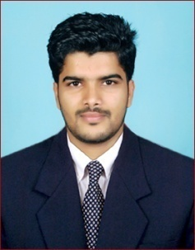
RASHID
Email: Rashid-393055@2freemail.com

Career objective
To obtain a position that will allow me to utilize my technical skill, experience and willingness to learn in making an organization successful.

Personal Skills
- Confident, Team Player
Computer skill
- Programming languages: C,C++,JAVA
- Operating System: Windows XP, Linux
- Packages : Microsoft Office

Certification Courses
Cisco Certified Network Associate (CCNA) – course completed
Cisco Certified Network Associate-Voice (CCNA-Voice) – course completed
Cisco Certified Network Professional-Voice (CCNP-Voice) - course completed
DIPLOMA IN COMPUTER APPLICATION (2011-2012)

Academics

- BACHILOUR OF COMPUTER APPLICATION (2012-2015) -63%
- PRE UNIVERSITY EDUCATION (2009-2011) -58%
- 10TH SSLC (2009) -53%

Technical Skills
- IP sub-netting and IP addressing
- Configuration and trouble shooting of routing protocol like RIP,OSPF and EIGRP
- Knowledge of IPCC
- Configuration of Voice Gateway and SRST
- Bulk Administration(BAT) of IP phones and IPCC
- Configuration of Extension Mobility
- Configuration of Media Resources
- Configuration of LAN and WAN
- Configuration of Call Manager Express(CME) on CISCO Routers
- Partition and calling search space(CSS)

Personal Details

DOB: 17th April 1991
Gender: Male
Language known: English, Hindi, Malayalam
Nationality: Indian

Declaration

I hereby declare that the information furnished above is true to the best of my knowledge and belief.

RASHID

