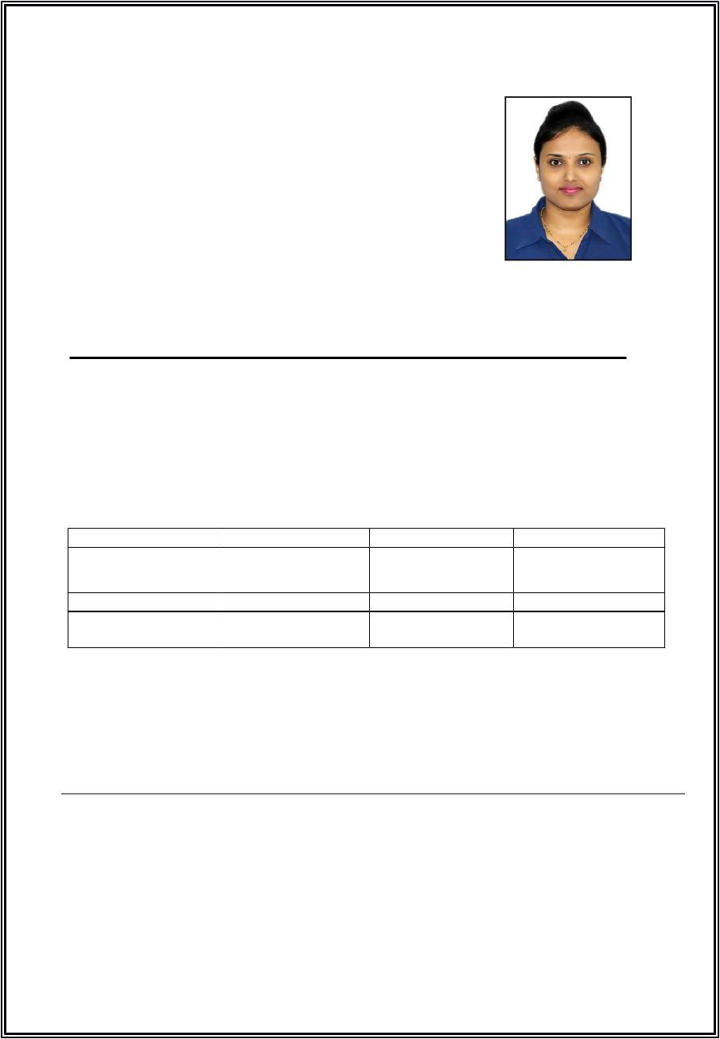
CurriculumVitae

RAJASHREE

VisaStatus:HusbandVisa

EMAIL: rajashree-393062@2freemail.com

CARREROBJECTIVE:

Seekingapositiontoutilizemyskilsandabilitiesinthe InformationTechnologyIndustrythatoffersprofessionalgrowth whilebeingresourceful,innovativeandflexible.

EDUCATIONQUALIFICATIONS:

COURSE | UNIVERSITY | YEAROFPASS | PERCENTAGE
B.E(IT) | MUMBAI | 2014 | 66.40%
 | UNIVERSITY
DIPLOMA(IT) | MSBTEBOARD | 2011 | 67%
S.S.C | MAHARASHTRA | 2007 | 77%
 | STATEBOARD

WORKEXPERIENCE:

- 2YEARSOFEXPERIENCEASANANDROIDAPPLICATONDEVELOPER
(JUNE2015-JULY2017).

ITSKILLS:

- JAVACertificationinCoreJava,AdvancedJavafromAPTECHCOMPUTER

EDUCATION.

Ø Language :C,C++,Java,Android

ØInternetApplication :WebTechnology

Ø OperatingSystems :Windows98,2000,7,8,XP,VISTA

STRENGTHS:

Hardworking

PositiveAtitude&Patience

GoodCommunicationSkils

Abilitytoworkinateam

PERSONALDETAILS:

TemporaryAddres | : | BurDubaiUAE
DateofBirth | : 28-04-1991
MaritalStatus | : | MARRIED
Nationality | : | INDIAN
LanguagesKnow | : | English,Hindi&Marathi

DECLARATION:

Iherebydeclarethattheabovestatedinformationistrueandcompletetothebest aspermyknowledge.

Date:

Place:

(RAJASHREE)

