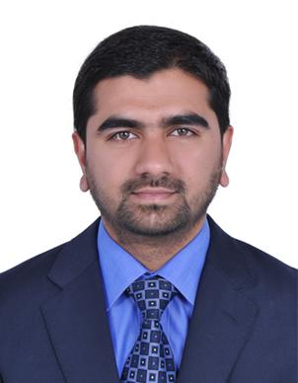

PERSONAL DETAILS

Name

: Nadeem

Date of Birth

: 19th May 1989

Visa Status

: Residence Visa

Gender

: Male

Marital Status

: Unmarried

Nationality

: Indian

Language Known

: English , Hindi and Odiya.

Email ID

: nadeem-393063@2freemail.com

OBJECTIVE:

Obtain a position as a team-player in a people-oriented Hi-Tech organization where I can maximize my customer-service experience in a challenging environment to achieve the organizations goals.

WORK EXPERIENCE:

Mechanical Engineer with an experience of 4 years as a consultant.

Currently working as a mechanical inspector from May 2017-till date.

List of Projects:

1.AZIZI Daisy, Freesia and Tulip

2.AZIZI Star hotel apartment

3.AZIZI Shaista and Samia

RESPONSIBILITIES:

- Responsible for implementations and monitoring of all mechanical related works such as plumbing , firefighting , HVAC and LPG systems at site .

- To inspect the work performed by Contractor and Subcontractors to verify that work is performed in accordance with contract plans and specifications, approved shop drawings and approved work plans

- Prepare daily field reports and maintain quality assurance logs detailing work performed any deviation from plans, unforeseen conditions, and any non-conforming work

- Maintain time and material records for changes as necessary

- Monitor correction of non-conforming work by the general contractor

- Review and comment on execution packages and contractor work plans

- Report any non-compliant conditions to the contractor management and construction manager

- Testing and Commissioning of mechanical services.

- Dealing with daily site reports, inspection requests, estimates and all applicable monitoring reports on regular basis or as required

- Providing technical and administrative support through all phases of the project

- Assisting Client, Engineering Consultant team and Contractors by responding to technical queries

- Attending site meetings and site reviews complete with reports

- Progress billing reviews

PREVIOUS EXPERIENCE

Worked as a mechanical engineer in India from August 2015 till February 2017.

ACADEMIC QUALIFICATION:

- Bachelor of Mechanical Engineering (North Maharashtra University,2015)

PROFESSIONAL TRAINING & CERTIFICATIONS:

- Training at I.G.T.R Indore on CNC machine.

- Having knowledge in Autocad , MS Office.

STRENGTHS:

- Problem solving capability.
- Willing to learn new things.
- Dedicated to work as a team.
- Good public relation.
- Sincerity.

DECLARATION:

I hereby declare that the information provided by me is true to the best of my knowledge and belief.

