NEHA
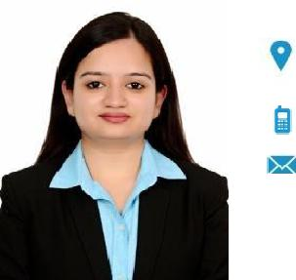

On Visit Visa expiring in Sept., 2019 Currently residing in Dubai, UAE

Neha-393084@2freemail.com

SEX Female | DATE OF BIRTH 08/06/1998 | NATIONALITY Indian

CAREER OBJECTIVE

To work with an organization which offers a challenging opportunity to enhance my knowledge, skills and experience that would allow me to contribute towards achieving the organizational goals to the best of my potential. Dedicated and motivated to join a reputable, growth-oriented company.

WORK EXPERIENCE

Dec.'18-Feb.'19 Faridabad (India)
Human Resource Intern

Maintaining employees' database & MIS, drafting birthday e-mailers, on-boarding documentation, etc.

Aug.'18-Nov.'18

New Delhi (India)
Human Resource Intern

Job portals, interviewing, HRIS, file movement, documentation, background verifications & reference checks, joining & exit formalities, handling social media, content writing & MIS for insurance, etc.

June'18-Aug.'18
Human Resource Intern

Maintaining employees' database & MIS,
drafting a CSR report, etc.

YOUTH EMPOWERMENT June'18-July'18
FOUNDATION, New Delhi (India)

Content Writing Intern

Writing on social & societal issues.

PRIMOTECH ENERGY Dec.'17-Jan.'18
SOLUTIONS PVT. LTD.,
Noida (India)

Human Resource Intern

Jobportals,interviewing, | recruitment,
documentation, maintaining MIS, etc.
DELHI METRO RAIL | June'17-July'17
CORPORATION LTD.,
New Delhi (India)
Human Resource Intern

Cashless medical policy processes, taking up employees' queries, maintaining MIS, etc.

EDUCATION & TRAINING

BACHELOR OF BUSINESS | 2016-2019

ADMINISTRATION (GENERAL)

Maharaja Surajmal Institute, GGSIPU, New
Delhi (India)

CGPA: 8.29/10

HR GENERALIST CERTIFICATE |  |  |  | 2019
Aptron Solutions Pvt. Ltd., Noida (India)
INTERMEDIATE |  |  |  | 2015-2016
St. Andrews Scots Sr. Sec. School, New
Delhi (India)
PERCENTAGE: 71.2%
MATRICULATION |  |  |  | 2013-2014
St. Andrews Scots Sr. Sec. School, New
Delhi (India)
CGPA: 9.2/10
PERSONAL SKILLS |  |  |  | _

Communication Skills Human Resource

Organizational/Managerial MS Office Skills

HRIS Internet & E-mails

EXTRA-CURRICULAR PROFILE

- United Nations Volunteers.
- Discipline coordinator in GENESIS 2018.

- Team member of Entrepreneurship Cell, Maharaja Surajmal Institute in 2017-18.

