RESUME

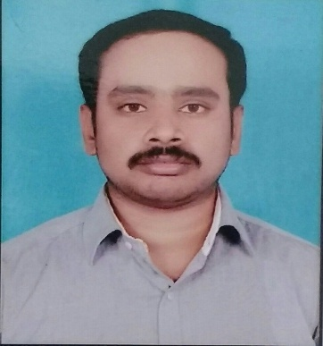

E-mail: gulfjobseeker-393090@2freemail.com

Objective
To be a member of any organization where growth, prospects are unlimited and individuality is recognized. As a professional, am creative, reliable, innovative and looking ahead in a challenging environment and strive hard for excellence.
Academic Background
B.E– Electrical and Electronics Engineering,
Institution Name : E.G.S PILLAY ENGINEERING COLLEGE,
University : ANNA UNIVERSITY
Percentage : 67% Duration : 2005-2009

Technical Skills
- Software : AUTO CADD, MS-powerpoint, MS-wordpad, MS-Excel
- Operating System : Windows.

Certifications
- NEYVELI LIGNITE CORPORATION LIMITED (GOVT OF INDIA)
- AUTO CADD and ELECTRICAL CADD

SPECTRUM OF KNOWLEDGE & EXPERIENCE
- Good grasping capability and understanding the concepts clearly.
- Ability to adjust to the situation.
- Sense of Responsibility and a very hard worker.
- A self motivated team player with good confidence and commitment.

Academics Projects
Title: Railway Traction and Control System using PLC and SCADA

Work Experience

Designation :Asst.Engineer and AUTOCADD Engineer
Period of working : May 2009 to May 2013
Explanation : single line diagram, project erection
related documents and manpower management

Designation :Electrical Maintenance Engineer
Period of working : June 2013 to Still now
Explanation : know about circuit breakers and its process,
Conveyor system and its arrangements,
Load sharing details of motors, trouble shooting and
Breakdown RCA reports.

.
Personal Details

Date of Birth : 14thOctober 1987
Age : 30 years
Sex : Male
Nationality : Indian
Languages Known : Tamil , English , and Hindi

