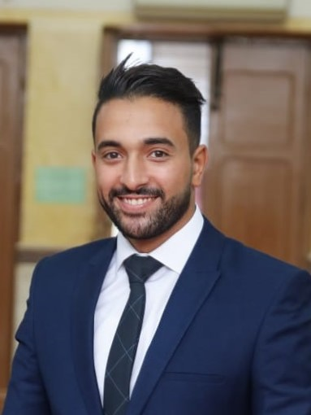
(civil Engineer)

Address :Egypt
Email Address : gulfjobseeker-393123@2freemail.com
ـــــــــــــــــــــــــــــــــــــــــــــــــــــــــــــــــــــــــــــــــــــــــــــــــــــــــــــــــــــــــــــــــــــــــــــــــــــــــــــــــــــ
Career Objective:
Seeking a Position In a Reputable Institution where I can Utilize
MyTechnical And Personal Skills In Achieving Both Organizational
And Personal Goals, As Well As Further Enriching My Relevant Knowledge AndExperience.
ــــــــــــــــــــــــــــــــــــــــــــــــــــــــــــــــــــــــــــــــــــــــــــــــــــــــــــــــــــــــــــــــــــــــــــــــــــــــــــــــــــــــــــــــــــــــــــــــــــــــــــ
Personal Information:
Birth Date 6 September 1992
Gender Male
Nationality Egypt
Marital Status Married
Military status Done
Driving license Egypt
ــــــــــــــــــــــــــــــــــــــــــــــــــــــــــــــــــــــــــــــــــــــــــــــــــــــــــــــــــــــــــــــــــــــــــــــــــــــــــــــــــــــــــــــــــــــــــــــــــــــــــــ
Educational Qualifications:

Qualification: Bachelor'of civil engineering (Zagaziguniversity)
Graduation project : Soil and Foundation (Excellent)

Degree of graduation: good

Year: 2014
ــــــــــــــــــــــــــــــــــــــــــــــــــــــــــــــــــــــــــــــــــــــــــــــــــــــــــــــــــــــــــــــــــــــــــــــــــــــــــــــــــــــــــــــــــــــــــــــــــــــــــــ
Computer skills :
AutoCAD
SAP2000
ICDL
Csi column

Experiencetrainning:

Company: The Arab Contractors co.
project: Aboushalabywater treatment plant

Company:Morad co. for construction
Project : Residential tower

Jan 2016 to jan 2017
Executive engineer for water treatment plant 70000m*3/day.
Jan 2017 to feb 2018
-Executive engineer for the construction
-working at Eng /as A quantity surveyor engineer.
Feb 2018 to Aug 2018
-Working at
KSA.
Sep 2018 to Dec 2018
-Executive for SamaMisr Co. at New capital .
Dec 2018 until now
-Executive engineer water treatment plant 25000m*3 /day .

ExperienceWork :
Personal Skills :-
- Hard Worker
- Extremely Motivated
- Dynamic and Ambitious
- Work Under Pressure
- Solve the Problems
- Leadership Team
- Social
ـــــــــــــــــــــــــــــــــــــــــــــــــــــــــــــــــــــــــــــــــــــــــــــــــــــــــــــــــ
Languages:
- Arabic : Mother Language
- English : spoken “Good “Written “Good
Available upon Request

