CURRICULUMVITAE  SHIKHIL  Email: shikhil-393128@2freemail.com  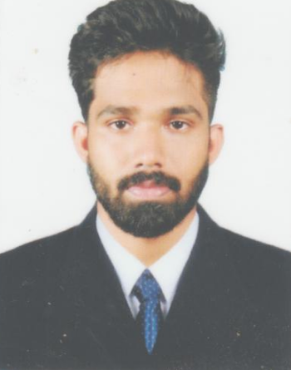  Date of Birth :26.08.1994  Nationality : Indian  Marital Status : Single | Career Objectives  To learn and function effectively in an organization and be able to deliver to the bottom-line , To constantly upgrade my knowledge and skill and make a difference in whatever I do  Professional& Academic Skills  - Accounts Receivable - Accounts Payable  - Accounting - Taxation  - Tally Erp Software - Task Accounting Software  Academic Qualifications  QUALIFICATION BOARD /University YEAR OF PASSING  PG (MCOM) KANNUR UNIVERSITY 2017  DEGREE (BCOM WITH TAX) KERALA UNIVERSITY 2015  PLUS TWO (COMMERCE WITH CA ) BOARD OF HIGHER SECONDARY EXAMINATION KERALA 2012  SSLC BOARD OF PUBLIC EXAMINATION KERALA 2010  Work Experience  Position : Assistant Accountant  Duration: 3rdAug-2018 to 15th June-19  Job Profile : The Main responsibilities include Place : Bangalore India  - Maintain Day to day accounts Transactions in Task Accounting Software  - Prepared Journal Entries for month end transaction.  - Posts customer payments by recording cash, checks  - Updates receivables by totaling unpaid invoices.  - Verifies validity of account discrepancies by obtaining and investigating information from sales& customer place  - Resolves valid or authorized deductions by entering adjusting entries.  - Prepare SOA & send to the customer  - Regular follow up with customer as per the credit terms and maintaining individual log sheets.
Computer Qualification, experience

- Tally Erp
- Task
- MS Excel,
- MS Word

Personal Strengths

- Discipline , Good Communication Skills , Hard working
- High Sense of Commitment

Extra curricular

- NCC A Certificate Holder
- Gym Trainer

Linguistic Abilities
S L NO. | DESCRIPTION | SPEAK | WRITE | READ
1 | English | Excellent | Excellent | Excellent
2 | Malayalam | Excellent | Excellent | Excellent
3 | Hindi |  | Excellent | Excellent
Personal Details
Name : SHIKHIL
Date of Birth : 26-08-1994
Gender : Male
Nationality : Indian
Religion : Hindu
Marital Status : Single

Declaration
I am confident of my ability to work in a team. I hereby declare that the information furnished above is true to my knowledge and I bear the responsibility for the correctness of the above mentioned particulars.

