7/22/2019
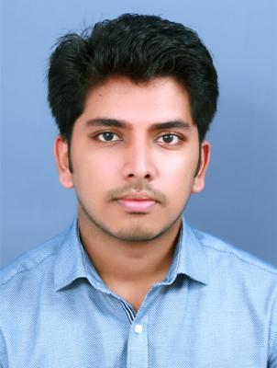

SACHIN

MECHANICAL ENGINEER

Sachin-393137@2freemail.com
Date of birth 26/03/1994 Indian

Visa Status: VISIT VISA(Valid till: 22 October 2019)

Work experience

From December | Service advisor
2017 to January
2019

Education

From August | B Tech in Mechanical Engineering
2013 to June | Adi Shankara Institute of Engineering and Technology
2017 | Kalady
 | CGPA-6.04

From July 2010 | 12th
to March 2012 | Jyothi Nivas Higher Secondary School Aluva
 | Percentage-65.4%
From June 2005 | 10th
to March 2010 | Al Ameen Public School Sreemoolanagaram
 | CGPA-8.6

Main project undertaken for B tech

Engine Exhaust Refrigeration System

Industrial training

•Audi services, Kochi(6 days)

•FACT, Kalamassery(5 days)

Special Training Programs

•Workshop on 'BOSCH Engine Maintenance and Services' •Autodesk certification for AutoCAD
•Certified in CATIA V5 by CADD CAMPUS India

1/2

7/22/2019

Interests

Travelling

Social Networking

Listening music

Industrial visit

Tata tea museum, Munnar

Tolins tyres, Angamaly

Kamco, Athani

Anavadya Electricals, Ernakulam

IT/Technical Skills

Computer language: C, C++

Application software: Microsoft Oﬃce, Solid edge

Awards and achievements

•Best final year project 2013-17 (Engine Exhaust Refrigeration System).

•1st prize for 'ANIMATION' held at ASIET as a part of Brahma 2014.

•1st prize for ‘ROBOWAR’.

•Secured B+ grade in Business English and Development Assignment for training under the Infosys Campus Connect Business English Program held at ASIET.

Leadership

Event coordinator for the college tech fest Brahma 2017

About me

Gender: Male

Nationality: Indian

Languages knew: English, Malayalam and Hindi

Marital Status: Single

Blood Group: B+

2/2

