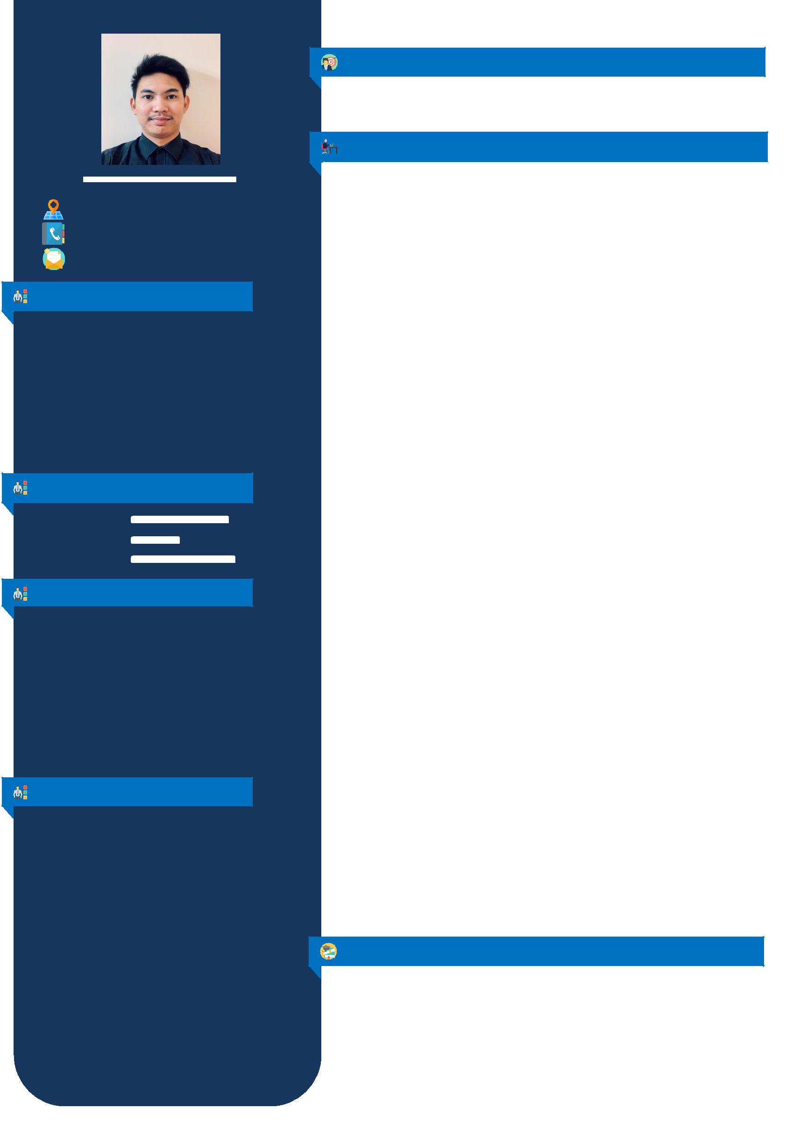
JOEL

`

Joel-393139@2freemail.com

PERSONAL INFORMATION

Date of Birth: November 20, 1993

Age: 25

Nationality: Filipino

Gender: Male

Civil Status: Single

Religion: Roman Catholic

Height: 5” 9’

Weight: 75 kg.

LANGUAGE SPOKEN
❖ English
❖ Arabic
❖ Tagalog

PERSONALITY
- Self - Motivated

- Hardworking

- Patient

- Creative

- Communicate

- Multi – Tasking

- Flexible

- Work Ethic

SKILLS

- Microsoft Application ( , , , , etc…)
- Networking

- Troubleshooting

- Adobe Photoshop

- Adobe Premiere Pro

- Basic HTML or web Programming

OBJECTIVE

To obtain a position where I could apply my skills and knowledge I’ve learned and to give an opportunity to work productively and accurately in your company.

PROFESSIONAL EXPRIENCE

ADMINISTRATIVE OFFICER

May 21, 2016 – May 31, 2019

Riyadh, Saudi Arabia

- Carry out administrative duties such as filing, copying, binding, scanning etc.

- Manage phone calls and correspondence (e-mail, letters, packages, Fax, etc...).

- Maintain supplies inventory by monthly checking stock to determine inventory level; anticipating needed supplies; placing and expediting orders for supplies; verifying receipt of supplies.

- Preparing price quotation for the request stationary item.

- Counting the entire stock Stationary item every end of the month for the Inventory Report.

- Receiving all sample items from warehouse for checking and approval.

- Printing ID badge request for team member use.

- Encoding and Issuing DC Card to the Operation Dept. for DC store’s uses.

- Preparing and submit Weekly/Monthly Sales.

- Preparing and Submit monthly report’s (Stock management and variance, Fixed Asset,

Due Payment, Invoices, Stationary request).

- Perform daily task assign.

OPERATION COORDINATOR -

August 11, 2014 – March 14, 2016

Clark Pampanga, Philippines

- Coordinates/liaise with Subcontract and clients for their order flow every season

- Preparing a report for entire order every season (Quantity, Price, Process, Shipment Production) to be submit on Subcontract/production

- Tracking all upcoming shipment trims and accessories needed on production.

- Provide all required trims and accessories for production

- Submit the sample design (Print/Embroidery) to the buyer’s for checking and approval.

- Collecting all approve materials received from the buyer and submit to production

- Preparing all receive Garment Sample for pre-production sample (PPS)

- Manage phone calls, e-mail(outlook)

CUSTOMER SERVICE (OJT Trainee)

accumulated 360 training hours

Pampanga, Philippines

- Providing and assisting all customers need for applying their business requirements.

- Creating and Issuing Tax Identification No. (TIN ID)

EDUCATION

Tertiary: Don Honorio Ventura Technological State University

Bachelor of Science in Information Technology

S.Y. 2010 – 2014

Pampanga, Philippines

Secondary: Don Honorio Ventura Technological State University

S.Y. 2006 – 2010

Pampanga, Philippines

I hereby certify that the above mentioned information is true and correct to best of my knowledge.

