NELLY
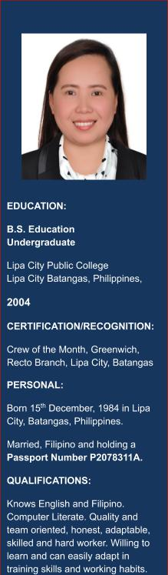

● | Email Add. | : nelly-393143@2freemail.com

CAREER OBJECTIVE

To be associated with a progressive company where I can build a career with committed and dedicated people, which will be of assistance in developing and utilizing my skills.

WORK EXPERIENCES:

Date Inclusive

Position

​

: June 18 2017 - June 18 2019

: Sales Advisor | Cashier Counter

- Greet customers at the store and provide them with information on their required products.

- Lead customers to the desired shelves and assist them in locating products.

- Explain products features and benefits by performing demonstration and answer any questions that customers may have.

- Suggest additional products in a bid to meet the company’s and self-sales target.

- Lead customers through the payment process by assisting cashiers with discount information and markdowns.

- Oversee the cleanliness and replenishment of shelves according to marketing and sales directive.

Company

Address

Date Inclusive

Position

: ​CITIMART DEPARTMENT STORE
: Bay City Mall, Batangas

: February 2006 – December 2008

: Sales Assistant | Cashier Counter

- Welcomes customers by greeting them; offering them assistance.

- Direct customers by escorting them to racks and counters; suggesting items.
- Advises customers by providing information on products.

- Helps customer make selections by building customer confidence; offering suggestions and opinions.
- Documents safe by creating or updating customer profile records.

- Processes payments by totaling purchases; processing checks, cash, and store or other credit cards.
- Contributes to team effort by accomplishing related results as needed.

NELLY 1

Company

Address

Date Inclusive

Position

: ​GREENWICH RECTO
: Lipa City, Philippines

: April 2003 – December 2005

:Customer Assistant Service Crew | Cashier

- Greets and welcome customers.

- Delivers the best customer service to all customers.

- Promotes up-sell and do suggestive selling to customer to increase sales.
- Maintains and follows correct hygiene practices especially in food handling.

- Displays products according to the plan.

- Prepares and organizes the things needed in the counter area.

- Cleans and sanitizes all equipment regularly.

- Ensures that the cash money is always counted properly.

NELLY 2

