Dr SOHAIL  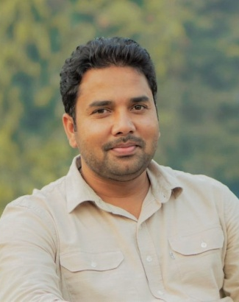  CONTACT  Email:  Sohail-393144@2freemail.com  PERSONAL INFORMATION  Date of Birth:  01-02-1985  Marital status:  Married  Religion:  Islam  Nationality :  Pakistani  LANGUAGE PROFICIENCY  English - Fluent  Urdu - Fluent  Punjabi - Fluent  Mewati - Fluent |  | OBJECTIVE  Extremely motivated and dedicated to work in a well-reputed company, where my exceptional agricultural and dairy farming skills and abilities are challenged. Wish to gain more experience in livestock and prove an asset to the organization.  WORK EXPERIENCE  12/2015 - 04/2019  Farm Manager  Responsibilities:  - Provision of professional and technical advices and management various units at farm.  - Supervision of animal feeding, milking parlor, animal breeding, calf management, human resource management, and animal health and forage conservation.  - Managing fodder crops and ensuring crop rotation in a way to avoid fodder shortage  - Ensuring food safety & quality standards along with compliance in all areas.  - Ensuring farm profitability by optimal usage of the existing resources at farm.  - Drive the adaptation of sustainable agricultural practices  - Implementation of farm safety standards both for farm employees ad animals  - Annual cost estimation (ACE) of the dairy farm and monthly dynamic forecast of the farm profitability.  - Contribution to develop rural community where farm is operating.  - Hands on training of dairy professionals and farmers during farm training sessions  09/2010 – 12/2015  Dairy Hub Development Executive  Responsibilities:  - Capacity building of farmers through simplified trainings, agriculture services, cooling and testing equipment, which creates unity among community smallholders to supply their milk and link to the formal sector and adopted dairy farming as full time commercial business  - Increase animal yield and effective control of animal diseases and produce quality milk.  EDUCATION  2005 – 2010  - Doctor of veterinary Medicine, University of veterinary & animal’s sciences Lahore, Pakistan.  2003 - 2004  - B.Sc. (Zoology, Botany & Chemistry). University of the Punjab Lahore.  2000 - 2002  - Intermediate (F .Sc. Pre medical), Govt. Islamia college civil lines Lahore.  Experiences/Awards  - Training on Cow management and nutrition by USDA in Alabama A&M University in 2017. Cow farm visits in Kentucky and Tennessee with respect to cow management.  - Practical training by international experts on hoof trimming, breeding, cow comfort, calf management, milking and maize agricultural practices through IFC (International Finance Corporation) program.  - Lean Farming training by International expert at Nestle Sheikhupura factory in order to achieve excellence in operation by eliminating wastes.  - Three days National training in UVAS on ultrasonography.  - One-week training program on dairy management in LUMS.  - Three months Internship in Australian Agriculture Sector Linkages program ( ASLP)  ADDITIONAL SKILLS  - Demonstrated ability to work well, with people and work well under Stress and follow complex plans strategies.  - Excellent MS Office skills.  - Demonstrated excellent communication and writing skills, and ability to work well in minimal supervision.  - Adaptability  REFERENCES  Available on request

