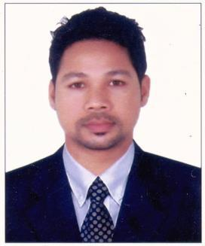

ZAVED

Zaved-393155@2freemail.com

Career Objective

A challenging position that will utilize my skills and experience in a company for growth and ... Seeking to join a progressive organization, where I may utilize my experience and skills for professional growth.

SKILLS :
 |  | Sales and marketing | Product and service sales
 |  | Cold calling skills | Converting leads
 |  | Networking skills | Client development
 |  | Vendor relations | Self-motivated
ACADEMIC
Year |  | Course | Institute | %
 |  |  | The Antartic English School, Manipur,(NIOS)
2006 |  | XII |  | 72.6%
2003 |  | X | The Antartic English School, Manipur,(NIOS) | 64.4%

WORK EXPIRENCE:

 | JUNE 2018 till March | 2019
Place: Bangalore | 11th Months
Designation: Sr. PRINCIPAL CONSULTANT
Department: Sales

- Evaluated inventory and delivery needs, optimizing strategies to meet customer demands.

- Increased sales by fostering relationships with customers, implementing business strategies and suggesting areas for improvement.

 | April 2017 Till 7-March 2018.
Place: Bangalore | 11th Months
Designation: Senior Executive
Department:Sales

Key Highlights

- Cold calling to arrange meetings with potential customers to prospect for new business.

- Organizing & conducting outdoor workshops for lead generation

February 2016 to Aug, 2016

Place: Bangalore

Designation: Business Development Executive

Department: Sales

6 Months

Key Highlights

- Responsible for planning of day’s activity on the field to joint calls and corporate calls.

- Achieving monthly revenue targets.

- Set the sales target and define strategy to achieve this target.

- Making presentations/demonstrations to prospective clients.

April, 2012 to February 2016

Place: Bangalore
3/10months
Designation: Senior Relationship Officer
Department: Sales

Key Highlights

- Maintained Constant contact with key clients to develop services offering & answer need Making presentations/demonstrations to prospective clients.

- Negotiating as per the potential Clients and close the deal.

PERSONAL DETAILS:

Date of Birth: 16th
April, 1988

Marital Status: Unmarried

Languages Known: English & Hindi
Hobbies: Playing Cricket and Listening to Music.

DECLARATION:

I assure to serve in your organization to the best of my ability and state that the facts Stated by me in this document are true to the best of my knowledge and belief.

Place: Sharjah UAE Zaved

