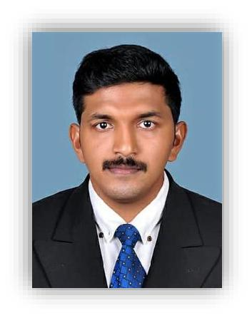
JITHIN

BTECH (MECHANICAL ENGG)

Email: jithin-393157@2freemail.com

CAREER OBJECTIVE

To work with an organization that provides an environment to improve the skills and knowledge along with organizational growth.

WORK EXPERIENCE

1.

Post

: Site Engineer

Duration

: 04/08/2017 to 31/05/2019

Client

: ISRO PROPULSION COMPLEX, Mahendragiri

Project

: Semi Cryo Integrated Engine Test Facility structural fabrication and erection

(4000 tonnes).

Roles and Responsibilities:
  - Lead Site Engineer for the project from 15/08/2017.

  - In charge of all the site.

  - Planning, scheduling and coordination of jobs.

  - Inspection and Documentation of Structural fit-up, welding with respect to structural drawings.

  - Supervising company staffs and providing technical advices.

  - Liaising with clients, subcontractors and other professional staffs..

Post | : | Site Engineer
Duration | : | 01/06/2016 to 30/06/2017
Client | : | Bharat Petroleum Corporation Pvt. Ltd.- Kochin Refinery.

Roles and Responsibilities:
- Inspection of pipelines, columns, vessels, oil tanks with NDT.

- Documentation works of inspection.

- Conducted various types of thickness survey in pipelines with assured quality.

- Evaluate isometric test drawings of pipelines and discuss inspection results with the clients.

- Coordinate inspection activities to meet completion target dates.

ACADEMIC QUALIFICATION

QUALIFICATION | INSTITUTION | UNIVERSITY/BOARD | PERCENTAGE | YEAR
B Tech | Caarmel Engineering College | Mahatma Gandhi University | 66.7 | 2016
₁₂th | Govt. Boys H.S.S | Kerala State Board | 88 | 2012
 | Kottarakkara
10th | R.V.V.H.S.S Valakom | Kerala State Board | 95 | 2010

PERSONAL QUALITIES
- Very good proficiency in Microsoft Office WORD, EXCEL, POWERPOINT, AUTOCAD, SOLID EDGE etc.

- Very good communication skills.

- Ability to work and produce best results under pressure situations.

PERSONAL DETAILS

Date of Birth | : 02-05-1994
Marital Status | : Single
Nationality | : Indian
Languages Known | : English, Hindi, Malayalam and Tamil.
Driving License | : India
Visa Status | : Visit visa (Expires on October 4)
DECLARATION

I hereby declare that the information furnished above is true to the best of my knowledge and belief.

Place: DUBAI

Date: JITHIN

