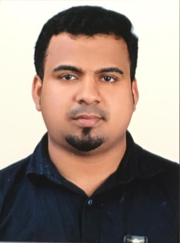

USMAN

Email: usman-393173@2freemail.com

CAREER OBJECTIVE

Association with a progressive and growing organization where my skills are realized and my knowledge can be enhanced for my personal development as well as for the benefit of the organization.

ACADEMIC PROFILE

BA (2004-2007) : University of Calicut, Kerala
HSE (2002-2004) : Higher Secondary Education Board, Kerala
SSLC (March 2002) : Education Board, Kerala

WORK EXPERIENCE
Sales Executive June 2017 - Oct 2018
Jeddah, Saudi Arabia
Sales Executive April 2010 - Oct 2016
Jeddah, Saudi Arabia

Duties and responsibilities:

- Greet customers happily and politely and satisfy their needs, request and queries;
- Ensure high level of customer satisfaction through excellent sales service and provide assistance and information on product features;
- Maintain in-stock and presentable condition of assigned area;
- Build productive and trust relationship with customers and increase the customer base by adding more customers to the store;
- Follow and achieve departments sales goals on a monthly, quarterly and yearly basis;
- Handle returns of merchandise;
- Comply with inventory control procedures;
- Ensure store is clean and tidy at all the time;
- Maintain friendly relationship with all the staff within the organization.
ADDITIONAL QUALIFICATION
CONSULTANCY WORK

- Good command over MS-Office, Internet and E-mail applications.

SKILLS

- Solid communication, customer service and interpersonal skills;
- Have excellent organizing, planning, analytical & problem solving skills.
- Negotiation and up-selling skills;
- Good computer skills and math skills;
- Fast learner and quickly pick product descriptions and key selling points;
- Good driving skills;
- Anticipate the needs and act appropriately in a fast paced environment;
- Practical, flexible and innovative approach to work;
- Multi tasking and good time management skills with the ability to prioritize the task.
- Team player and leadership skills.
PERSONAL DETAILS

Date of birth : 24 November 1985
Marital status : Married
Nationality : Indian
Visa status : Visit Visa Valid till 9th October
Languages : English, Arabic (Fluent), Hindi, Malayalam.
Driving License : Saudi License and Indian Heavy License

DECLARATION

I hereby declare that all the particulars furnished above are true and correct. I Promise that I will do my best, if you give a chance in your reputed concern.

USMAN

