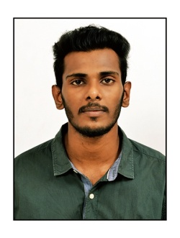
ANURAG

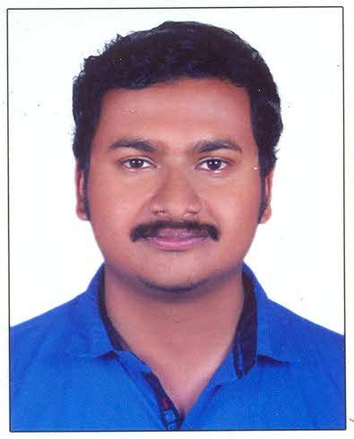
PERSONAL INFORMATION

OBJECTIVES

CONTACT
Highly skilled individual with 10 years of experience in working as company material in charge towards organizational goal.I am highly innovative and is often recognized as a result oriented and solution focused individual.I amlooking for a suitable position with a company which offers genuine room for progression and where I can make a significant contribution.

Anurag-393207@2freemail.com

Abu Dhabi, U.A.E

EDUCATION

- SSLC & Plus Two–Govt. of Kerala-77%&70%
- Diploma in fire and industrial safety engineering-National safety council of India-60%
- Bachelor of Commerce – University of Calicut,Kerala-52%

KEY SKILLS

- Strong emphasis on accuracy and details
- Great Administrative skills and a quick learner
- Proficient in MS Office
- Strong communication skills
- Strong supervision ability
- Proficient in material analysis and performance

- Since 2009, working as Inward Material in Charge, handling petty cash and sales Executive in Abu Dhabi (10years).
- 2008 – Safety Supervisor in reputed Industry Larsen and Toubro Ltd (L & T), India

Major Responsibilities

Designation: Material Incharge/cashier/sales Executive
- Materials Management function including inspection, storage, control and distribution of materials and products to meet Company objectives and customer requirements
- Direction and administering Purchasing , sales, Inventory Control, Shipping and Receiving, Customer Contact and Material Stores
- Ensures that the company standard practices and procedures are followed in connection with all materials department functions.
- Handling accounts of cash transactions.
- L & T
Designation:Safety Supervisor
Major Responsibilities:
- Inspects the site to ensure it is a hazard-free environment
- Conducts toolbox meetings
- The safety officer reviews and approves all subcontractors safety plans

Age & Date of Birth : 30 years, 16th November 1988
Gender : Male
Nationality : Indian
Marital Status : Married
Visa Status : Job Visa (Transferrable)
Expires on 14th OCTOBER, 2019

I solemnly declare that the information furnished above is true to the best of my knowledge and belief.

Date:
Anurag

WORK EXPERIENCE

PERSONAL INFORMATION

I hereby declare that the above given information is true and correct to my best of my knowledge and belief.
DECLARATION
SHAFEEK V MUHAMMAD

