Vibin
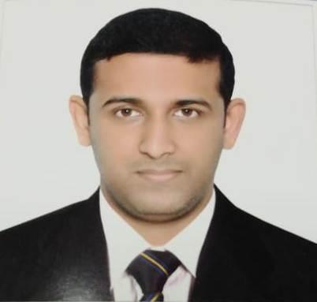

Position: Assistant Branch Manager
Experience: ​6 years

Educational Qualification: MBA in Finance and HR

Email: vibin-393212@2freemail.com

Current Location: Abu Dhabi, UAE

CAREER SUMMARY

- More than 6 years experience as Assistant Branch Manager in United Arab Emirates.

- About 2 years experience as Accountant in India

EXPERIENCE

Assistant Branch Manager Dec ’13 - Present

Abu Dhabi, UAE

- Monitoring the daily current currency rate in the market, settle on the buying & selling rate for each currency.

- Handling WPS registration procedures and assisting clients in processing their Salary.

- In charge of foreign currency deals and fixing the FC deals in competent rates.

- Providing fast, efficient and error-free remittance service to different countries.

- Handling customer enquiries, complaints, following up with them by providing accurate information to ensure resolution of products/service and maintain customer satisfaction in each stage.

- Timely monitoring marketing activities to corporate targets and corporate segments.

- Identifying, developing potential customer, or business.

- In the absence of Branch Manager, maintains communication between the branch and management by preparing daily, weekly and month end reports regarding operations and productivity.

- Formulates recommendations and provides feedback to the management regarding operational policies and procedures.

- Consistently received positive feedback from customers and created a repeated business by developing long term relationship with customers.

Accountant June ’11 – Mar ‘13

Kerala, India

- Verifying, allocating, posting and reconciling accounts payable and receivable.

- Producing error-free accounting reports and presents their results.

- Analyzing financial information and summarizing financial status.

- Provide technical support and advice on ​Management accountant​.
- Review and recommend modifications to accounting systems and procedures.

- Manage accounting assistants and bookkeepers.

- Participate in financial standards setting and in forecast process.

- Prepare financial statements and produce budget according to schedule.

- Develop and document business processes and accounting policies to maintain and strengthen internal controls.

EDUCATION

Master of Business Administration (M.B.A)

Mahatma Gandhi University, Kerala, India

Bachelor of Commerce (B.Com)

Calicut University, Kerala, India

CERTIFICATION COURSE

SAP Business One Training Programme​from Clockwork Academy

Diploma in Computerized Accounting Packages​from G-Tec Computer Education
COMPUTER PROFICIENCY

MS Office, Tally 9.0, & Peachtree

TRAINING ATTENDED

Anti-Money Laundering (AML) Workshop

Attended AML workshop on 12th July 2018, organized by the Foreign Exchange and Remittance Group (FERG).

PERSONAL PROFILE

Date of Birth | : 04/04/1987
Gender | : Male
Nationality | : Indian
Marital Status | : Married
Languages Known : English, Hindi, and Malayalam
Visa Status | : Employment (Notice Period – 15 days)

