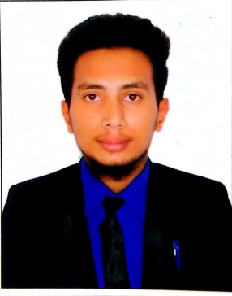

WALID

Email id: walid-393229@2freemail.com

Career Objective:

To gain exposure to the best professional practices with hands-on experience. To achieve the organization’s as well as my personal goals.
Academic profile:
Course | Name of the school/ college | Board /  University | Year of passing
Diploma in computer application | Al-khair learning & computer center | A unit of al-khair society Golconda | 2015
IT-computer fundamentals, msoffice internet | KTI VOCATIONAL INSTITUTE | Board of Intermediate Education | 2019
SSC | Gowtham Model high School | Board of Secondary Education | 2017

Personal Assets:
- Good communication skills.
- Pro-active.
- Willingness to learn new things.
- Ability to cope up with changing environment.

Technical skill profile:
- Operating System : Windows XP,7,8
- Languages : Word, Excel, Power point)
- Packages : microsoft xp 2007

Additional skills:
- Good Listener
- Can work for hours together
- Time Management
- Flexibility
- Ability to achieve targets with determination and courage.

WORKING EXPERIENCE

Designation: Technician AND PROGRAMMER
Duration : 2 years

Job Responsibilities:

- Ability to configure and access control system.
- Installation and programming in CCTV analog and IP CCTV , fire alarm.
- Remote monitoring and network design for CCTV system.
- Technician and programming in BMS System( fiber optics, access control, intruder alarm).
- Ability to resolve Pa/BGM, PBX/IPBX intercom, parking management.
- Maintenance of IP CCTV, fire alarm.
- Installation and programming of access control and time attendance software.
- Installation and programming of intercom and public address for high rise buildings and villas.
- Worked on intrusion system, glass break detectors, infrared sensors, door contracts.
- Troubleshooting in fire alarm, IPCCTV, access control.
- Install cabling and devices for commercial network.
- Coax and IP cameras, wired security installations.
- Serviced access control on software house and access systems, power supplies, door strikes, card readers, mag locks etc.
- Ability to work on routers and switches.
- Computer (CAT -5/ CAT -6) twisted pair, cable wiring fire alarm.

Personal Profile:
Date of Birth : 23, March , 1999
Nationality : Indian
Languages Known : English, Urdu & Hindi
VISA STATUS : VISIT VISA
Declaration:
I hereby declare that the information furnished above is true to the best of my knowledge.

Place: Hyderabad Walid

