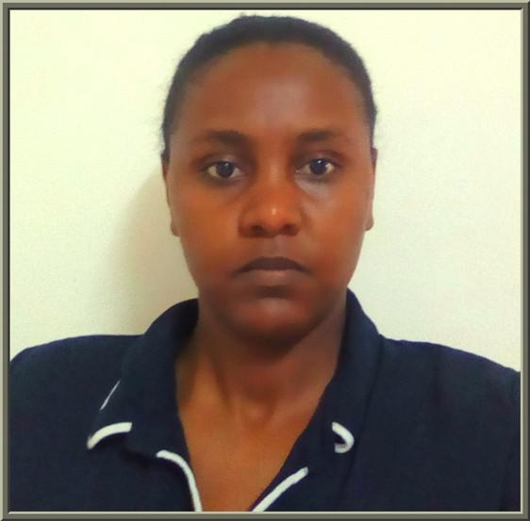
Curriculum Vitae

KHALDA

Email Id – khalda-393237@2freemail.com

Date of birth: 28/04/1992

OBJECTIVE

As a teacher I want to excel, entertain and deliver my lessons with ultimate love and devotion. Helping my student and inspiring them, as well as supporting them in any way possible.

Perfecting my translation skills.

Teaching students gives me a sense of satisfaction.

I am always looking for further academic qualification and training.

As a person I want to grow with life experiences and managing my time in a way that can fulfill my dreams.

EDUCATIONAL QUALIFICATION

KHARTOUM UNIVERSITY, ALGAMAA AVE SECOND HONOR DEGREE FIRST DIVISION 2009-2014

FOUR YEARS BACHELOR DEGREE IN ENGLISH DEPARTMENT. FIVE YEAR HONOR DEGREE IN LINGUISTICS DEPARTMENT. WITH OVERALL 71%.

GOETHE INSTITIUE, ALMAK NIMIR VVE B1 LEVEL

2011-2013

6 level’s of German language.

MA KHARTOUM UNIVERSITY,ALGAMAA AVE MA IN TESOL

2016-2017

IT IS 8 COURSES MA, AND ONE RESEARCH THESIS SEMESTER.

IELTS DEGREE, 6.5

LISTENING 8.5 READING 6 SPEAKING 7 WRITING 6 APRIL 2018

EXPERIENCE

2013- current position

English, Arabic and German translator

- Teacher assistant and coordinator Holm international school(kindergarten) July 2014- March 2015
SHORT COURSES PART-TIME TEACHER Comboni college 1 MAY 2015- 1 MAY 2016

Short courses teacher of adults’ teenagers and kids. Delivering a 2 hours class 3 times a week. Teaching a syllabus and making assessment at the end of the course. Correcting class work and homework. The aim was to enhance communication skills alongside with other language skills.

CLASS TEACHER ALTFAWUG PRIVATE SCHOOL 15 July 2015- July 2017

Teaching grades 5 and 6 all English (grammar, comprehension, spelling, hand-writing and literacy).

Full time teacher, monthly exams’ provider and parent’s meeting participator.

Teaching Center Invigilator British Council Sudan April 2018- present

English language Teacher American Discussion Club September 2018- present
SKILLS & ABILITIES

Experienced with IG and IB systems
English, Arabic and German translator.
Gentle and wise when dealing with children
Documents and conversational translation between English and Arabic. Patient teacher willing to develop herself in knowledge and practice.

A care giver teacher who care about her student's well-being.
Corporation team worker following the instruction of the administration and supervisors.

Course books and materials selector.
Working with mixed gender classes and classes of multi-cultural background Experienced in correcting exams and writing performance evaluation reports. Capable of effective participation in department’s meeting.

Culturally aware teacher with reasonable sensitivity. A good reader and creative writer.

Freelancer translator committed to the deadlines.
Working anywhere around the world and willing to adapt to several circumstances.

COMMUNICATION

Good presentation skills. Hosting events in and out of campus.
Volunteer in Alkhatim Adlan center for enlightenment -2011. Amal cultural group-2013.

Salima junior workshop 2013.
Karmacol international preparation workshop.
A member of SWARC feminist organization reading and movie club.

LEADERSHIP

Outspoken student with great academic performance and outer curriculum active participator.

Watchful and meticulous office worker and an error detector.
Excellent command of English and good German French and Italian user.
I am a poet and fiction writer. I am using my writing talent to change the world but I am not yet published on a considerable scale.
FUTURE PLANS

Sitting for IELTS again to have a better writing and reading grades. Obtaining Celta certificate.

Starting my Ph.D in American literature.

KHALDA

