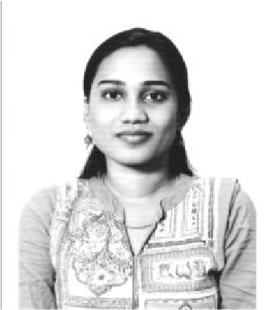Manju
Manju-393254@2freemail.com

OBJECTIVE

To obtain a challenging and responsible position in an organization, where I can contribute for the successful growth of an organization by using my abilities and knowledge.

EDUCATION QUALIFICATIONS

Exam /Degree | Year of  Passing | College/School | University / Board
B.sc Computer Science | 2014 | K.C.S KasiNadar College of Arts &  Science – Chennai – Tamilnadu - India | Madras  University
12th Board | 2011 | Our ladysHr Sec School –  Chennai – Tamilnadu - India | State Board
10th Board | 2009 | Government Higher Sec School – Chennai – Tamilnadu - India | State Board

EXPERIENCE

- Worked as a Senior Processor Executive in - Chennai – India during Dec’ 2014 – Sep’ 2017.
- Worked as SAP Associate in Chennai – India Jun’ 2018 – Oct’ 2018.

Training

- Undergone SAP MM & SD Module Training at Troy Infotech, Chennai – India

TECHINCAL SKILLS

- SAP R3 Version (7.0) Tool
- SAP Business One – 9.2 PL 08 to 9.3 PL 03
- SQL – 2012, 2014 & 2016
- MS Office
- Data Conversion Tool – DTW & LSMW
- Basics in Financial back End postings
- Knowledge in Multi Media Editing

SKILL SETS

- Conceptual knowledge in Sales Enquiry, Sales Quotation, Sales Order, Delivery, AR Invoices, Payments
- Conceptual knowledge in Purchase Requisition, Purchase Quotation, Purchase Order, Goods Receipt, AP Invoices, Payments
- Conceptual knowledge in Inventory Management
- Data Conversion using LSMW& DTW
- Basic Knowledge in System Software & Hardware

STRENGTH

- Hard working and goal oriented
- Ability to work as a Team
- Positive thinking
- Quick adjustment to new environment
- Committed to work in project deadlines and schedules.

CO-CURRICULAR ACTIVITIES

- Participated in Throw ball
- Painting

PERSONAL DETAILS
Nationality | : | Indian
Gender | : | Female
Date of Birth | : | 12th July 1994
Status` | : | Married
Hobbies | : | Listening to Music.
Languages Known | : | English, Tamil, Telugu

DECLARATION
I hereby declare that all the information and facts given above are true to best of my knowledge and belief.

Date: Your’s Faithfully

(Manjul)

