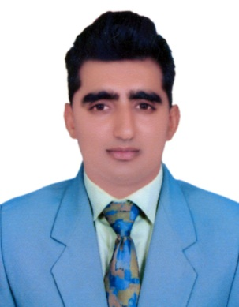
Akmal

Email: akmal-393260@2freemail.com
Date of Birth: 26-09-1990

Professional Summry
A professional and committed health and safety officer with all relevant qualification as well as extensive knowledge and experience in workplace. A through up to date knowledge of all health and safety legislation, including EU directives and codes of practice. Able to write policies and safe system of work to protect the health and safety of employees as well as the environment. A professional skilled in the site observation, planning and time management. A good communicator on all levels, happy to work alongside senior management contractors and external agencies, knowing how and when to liaise with various individuals.
Core Qualification

- Diploma In HSE Engineering Pakistan.
- OSHA certificate in General Industry safety and health, USA
- IOSH certificate in managing safely , UK
- Diploma in Safety Officer, Pakistan
- Certificate in fire safety, Pakistan

Professional Membership
- Member of occupational safety and health administration (OSHA)
- Member of Institute of occupational safety and health (IOSH)
English Proficiency

- Level I certificate in ESOL International (communicator B-II) UK
- IELTS , band 5.5- British council UK
Academic Qulification

- Beachlor of science, 2017 Pakistan
Bahau Din Zakriya University Multan.
- Level 5 Diploma in Information Technology, 2013 UK
London Essex College, UK
- FSc, pre-engineering, 2010 Pakistan
Board of Intermediate & Secondary Education Multan
- Matric In Science, 2007 Pakistan
Board of Intermediate & Secondary Education Faisalabad

Employment History

FRIENDS ASSOCIATES

- Job Title: Safety Officer
Project: Pak Arab Fertilizer Pvt Ltd. Multan
Duration: 2015 to 2017

Responsibilities

- Responsible for all aspects of health and safety and environment within the company construction site.
- Writing policies, procedures, safe system of work and risk assessments
- Study the building , equipment, procedures and records of accidents and point out safety hazards.
- Ability to work in stressful environment and under pressure.
- Keeping people free from danger.
- Ability to handle any kind of conditions.

Pakistan

- Job Title: HSE Engineer
- Project: AES Lal Pir Thermal Power Station
- Duration: 2017-19
Responsibilities
✓ Managing all aspects of health and safety within the company.
- Indentifying HSE Hazards and carrying out risk assessment.
- Accidents, incidents and claims management.
- Maintaining safety equipment (CCTV, alarms, first aid Kit Etc.)
- Carrying out routine workplace inspection.

