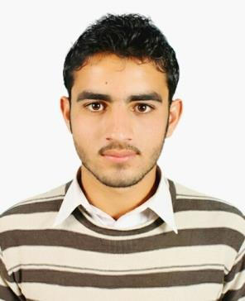
|Civil Engineer|

UMAR

E-mail: umar-393263@2freemail.com
Location : DUBAI (UAE) ON 3 MONTH VISIT

Objectives:-

Seeking a challenging position to utilize my skills and abilities in the area of Civil Engineering, which offers professional growth while being resourceful and innovative and enhance my skills and strength in conjunction with company goals and objectives.

Professional Experience:-

Project Duration Role

: Bunji 7200MW Hydropower
: May 2012 – August 2013

: Trainee Engineer

Job Profile:-

  - Conducting feasibility studies to estimate materials, time and labour costs
  - Preparing negotiating and analyzing costs for tenders and contracts
  - Feasibility studies of client requests
- • Analyzing completed work and arranging payment to contractors

  - Coordinating labour, material, equipment s and contractors to ensure on schedule, on budget completion

  - Site visits ,assessments and projections for future work

  - Preparation of measurement sheet and assists in quantity take off
  - Checks the allocation of manpower and productivity

PROJECT : Construction of Academic Block –II and Examination Block at University of
Swabi ( Package –II) New Campus”
Duration : JULY 2017 – JUNE 2019
Role : SITE SUPERVISOR

Job Profile:-

  - Prepared Auto-Cad plans for submission, coordinated engineering, estimating.
- • Conducted site survey and analyzed data in order to execute civil engineering projects.

  - Proper management of materials and workmanship.
- • Site inspection and ensure work is as per the project specifications.

  - Prepare drawings for set out.
- • Give order to purchase required material at various stage of construction.

  - Calculate cost, time and labour requirements for the projects.
  - Preparing weekly and monthly progress report to be submitted to the project director

Education:-

Bachelor of Technology in Civil Engineering

IQRA NATIONAL UNIVERSITY PESHAWER |PAKISTAN| |2013 – 2018|

|CGPA 3.00 Out of 4.00|1st division|

Diploma in Civil Engineering
GHAZI INSTITUTE OF TECHNOLOGY GHAZI(GADOON AMAZAI)
|2009- 2012|

|Obtain marks 2290 out of 3350|1st division|

SSC (SCIENCE)

KHYBER MODEL SCHOOL KOTHA SWABI (KPK) PAKISTAN |2009|

|Obtain marks 745 out of 1050|1st division|

Technical Skills & Competencies:-
• Microsoft Office Word, Microsoft Office Excel, Microsoft Office Power Point

  - Auto CAD 2D & 3D, Plan swift(basics)

Key Skills & Competencies:-
- • Willingness to learn

- • Quick learning and delivering solutions, has the ability to work in a fast paced environment

  - good team player
- • Excellent analytical & problem solving skill

  - Ability to handle multiple tasks with excellent technical and troubleshooting skills in Engineering drawings and principles

Personal Details:-

 | Nationality | : PAKISTAN
•
• | Province | : KPK
• | Marital status | : Single
• | Gender | : Male

Religion:-
- Islam

Language known:-
- English,Urdu,phostu

Declaration:-

