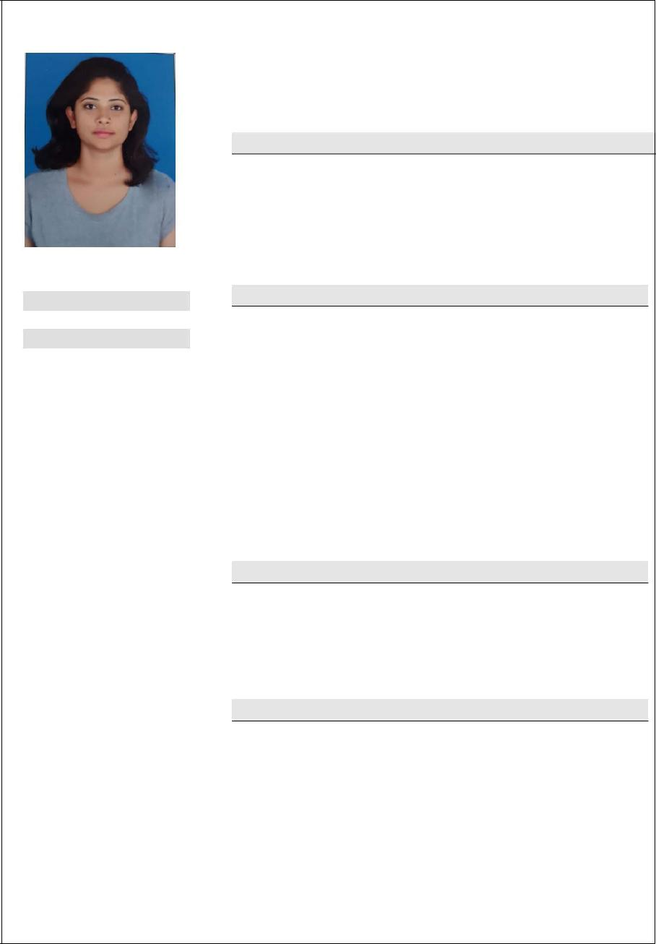
CURRICULUM VITAE

JEENA

Email ID

Jeena-393274@2freemail.com

.

PERSONAL DATA:

Date of Birth :20/05/1993

Sex : Female
Nationality : Indian

Marital Status : Married

Visa Status: Visit Visa

Mother Tongue: Malayalam

Languages known

English, Malayalam, Hindi

CAREER OBJECTIVE

To work in a firm with a professional work driven environment where I can utilize and apply my knowledge, skills which would enable me to grow while fulfilling organizational goals.

PERSONAL SKILLS

- Ability to accept any challenge with an optimistic outlook.

- Teaming up with the colleagues.

- Motivate and energise the team towards desired outcome.

- Strong sense of ethics and job responsibility.

- Willingness to learn.

- Hard working

EXTRA-CURRICULAR ACTIVITIES

❖
Served as a member of Bharat Scouts& Guides.

❖
Participated and won prizes in many inter-school competitions.

HOBBIES

- Listening Music

- Cooking

- Traveling

EDUCATIONAL QUALIFICATIONS:

 |  |  |  | Discipline/ |  |  |  |  |  |  | Board/
 | Examination |  |  |  |  |  |  | School/College |  |  |  |  |  | Year of |  |  |  |  |  |  | Percentage
 |  |  |  | Specialization |  |  |  |  |  |  | University
 |  |  |  |  |  |  |  |  |  |  |  |  |  | Passing
 | MBA |  |  | HR |  |  |  | New Horizon |  |  | Bharathiyar |  | 2017 |  |  |  |  |  |  |  | 65
 |  |  |  |  |  |  |  | College of |  |  | University
 |  |  |  |  |  |  |  | Engineering
 | B.Com |  |  | Commerce |  |  |  | Kairali College |  |  | Kannur |  | 2013 |  |  |  |  |  |  |  | 42
 |  |  |  |  |  |  |  |  |  |  | University
 |  |  |  |  |  |  |  |  |  |  | Board of
 | Plus-Two |  |  | Commerce |  |  |  | CHMS GHSS, |  |  | Higher |  | 2010 |  |  |  |  |  |  |  | 58
 |  |  |  |  |  |  |  | Valapattanam |  |  | Secondary
 |  |  |  |  |  |  |  |  |  |  | Education
 |  |  |  |  |  |  |  |  |  |  | ,Kerala
 | SSLC |  |  | SSLC |  |  | Parassinikadavu |  |  |  | Board of |  | 2008 |  |  |  |  |  |  |  | 80
 |  |  |  |  |  |  |  | High School |  |  | Public
 |  |  |  |  |  |  |  |  |  |  | Examinations,
 |  |  |  |  |  |  |  |  |  |  | Kerala

PROJECT DETAILS:

Project Title : RECRUITMENT AND SELECTION

Organization : Sakra World Hospital, Bangalore

Duration : one month

❖
IT PROFIENCY

- Microsoft Office

- Microsoft Excel
❖

PREVIOUS WORK EXPERIENCE

- Worked as ERC Associate on contract basis (2017 Sep to 2018 Jan)

- Worked as Business Process Services Practitioner from (2018 Aug to Apr 2019)

DECLARATION:

I hereby declare that all the statements made in the above Curriculum Vitae are correct to the best of my knowledge and belief.

JEENA

