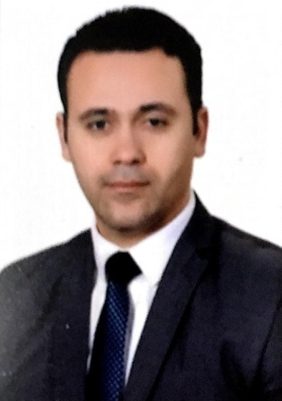
Essam
………

Essam-393356@2freemail.com
Dubai - UAE.

Skills
- Certified TEFL Instructor
- Certified trainer
- MS office proficiency
- Fluent in English
- 13 years as an ESL Teacher
- Teaching certificate
- Certified Generalist Teacher for primary
- 2 years as an ESL Instructor
- Extensive English grammar knowledge

- 2 years as an ESL Instructor
- Extensive English grammar knowledge
Professional Summary
- Enthusiastic English Teacher dedicated to creating an enjoyable, inviting and dynamic learning atmosphere.
- Implement traditional and innovative methods to motivate students to learn the English language.
- Caring and qualified Elementary School teacher with over 14 years of experience teaching meaningful curriculum plans and developing young minds.

Work History
09/2017 – 07/2018
Dubai, UAE
English Teacher
- Collaborated with teachers and department heads to meet quarterly and yearly educational goals
- Attended learning activities

09/2011 – 09/2017
Dubai , UAE
English Teacher
- Attended workshops to learn about student motivation and engaging learning activities.
- Emphasis Critical thinking through small group activities.
- Developed English Lesson plans in line with the national curriculum: Plan English lessons to meet curriculum standards.

05/2009 – 09/2011
Dubai, UAE
English Teacher
- Administered and graded tests and assignments to evaluate student progress.
- Managed several internet-based language programs.
- Helped students understand, speak, read and write in English.
- Modified assignments and activities to meet the learning needs of individual students – Identified and sorted into small, similarly skilled groups.
- Took part in the school quality assurance – Attend and contribute to school meetings and weekly briefing – Work as a team supporting school teachers in spreading and sharing good practices.
- Engaged in the self-review processes together with the school management.

EDUCATION

Minia University | Egypt.
B.Sc. of Education: English

Minia University | Egypt.
Diploma of Education: special need

07/2003 – 03/2009
Dolkam For Basic Education | Minia , Egypt.
English Teacher
- Collaborated with teachers and department heads to meet quarterly and yearly educational goals
- Worked with an average of 45 students per class.
- Deliver engaging, coherent lectures and motivating lessons to students across all Key Stages. Utilize learning technology in the planning and delivery of lessons.
- Communicated with parents, students and the teaching administration – Met with students, parents and other educators on a constant basis to discuss student progress.

01/2019 – Current
ICT academy |
English Trainer

certifications
- TEFL Diploma (ATLANTA INSTITUTE IN AMERICA 120 HR)
- TKT (TEACHING KNOWLEDGE TEST) CAMBRIDGE
- TOT (TRAINING OF TRAINERS) AIN SHAMS UNIVERSITY

