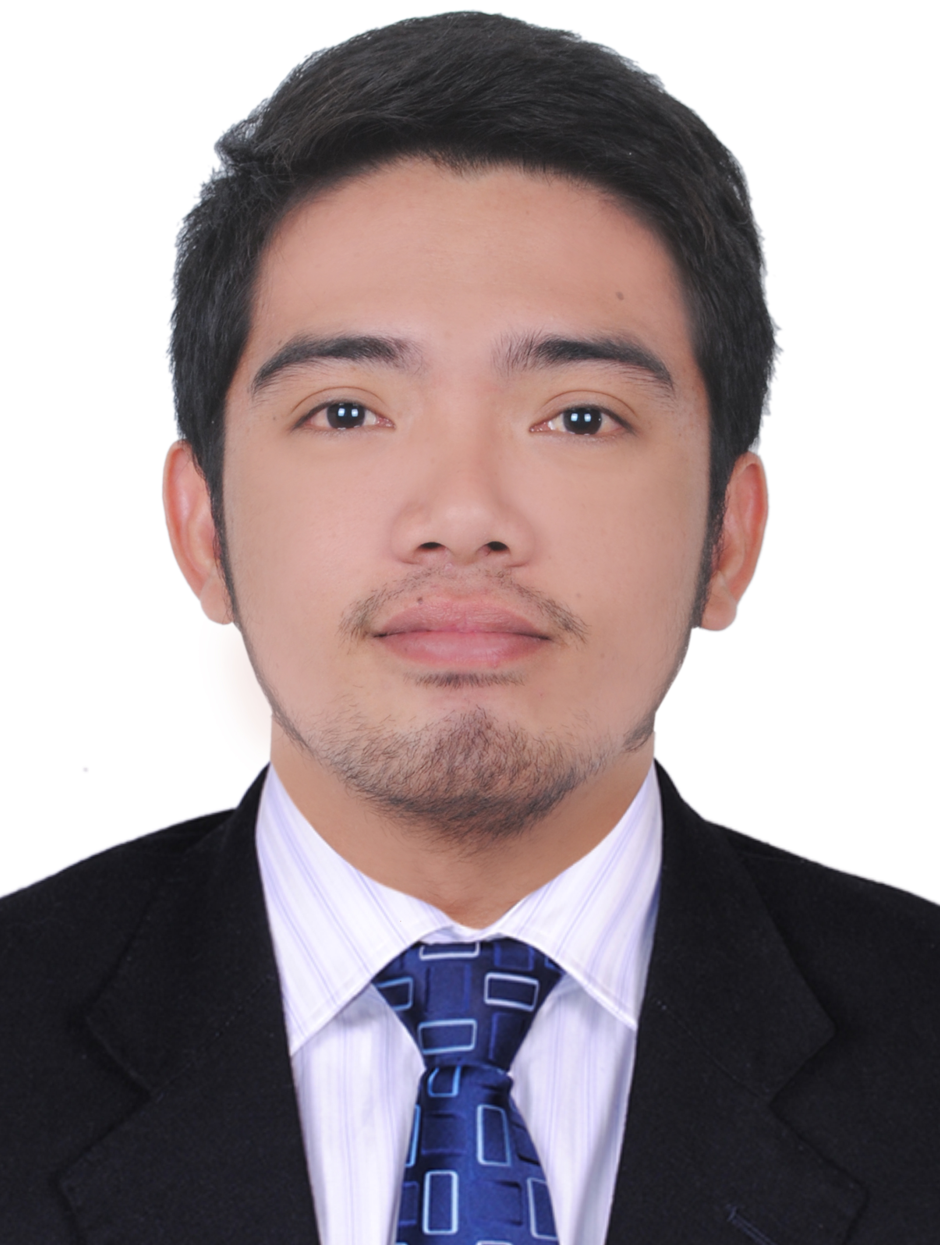  JERIC  E-MAIL ADDRESS:  Jeric-393370@2freemail.com  Visa Status: Tourist Visa  SKILLS:  - Communication  - Computer Skills  - Customer Service  - Attention Details  - Organizational Skills  - Operating system  - Word processing  - Data applications  - Data sorting  Languages Known:  - English  - Tagalog  PERSONAL DATA:  Date of Birth: November 06,  1996  Gender: Male  Nationality: Filipino  Religion: Christian  Status: Single | CAREER OBJECTIVES  Seeking for fast pace, and challenging environment. To join in a progressive organizational management and offers opportunities for advancement.  SUMMARY  Recent Information Technology student graduate with experience as a back office clerks, retail and management. Provide genuine commitment to quality satisfaction with strong attention detail.  EMPLOYMENT RECORD:  South Cotabato Philippines  Desk Clerks  2018  Job Description:  - Answer phone calls, filling, data processing, faxing running errands, sorting incoming mail.  - Communication with customers, employees, and other individual answered.  - Compile and copy, sort, and file records of office activities.  - Operate office machines, such as photocopiers and scanners.  - Review files and records, other documents to obtain information request.  - Complete duty schedules, manage and arrange appointments.  - Troubleshoot problems involving office equipment, such as computer hardware and software.  Koronadal City  Service Crew/Waiter  2018  Job Description  - Responsible day to day full service with coordination and planning.  - Provide service with strategic-leadership and direction for current future.  - Pleasantly and integrated honest while interacting guest.  - Responsible assigned duties related company agreement and management rules.  Sales Associate/Representative  Job Description  - Generating Leads.  - Meeting or exceeding sales goals.  - Giving sales presentation to a range of prospective clients.  - Responsible assigned duties related company agreement and management rules.  - Answering client question about credit terms, products, prices and availability.  EDUCATIONAL ATTAINMENT:  Bachelor of Science Information Technology  Ramon Magsaysay Memorial College  Graduated year/2019  CERTIFICATE TRAINING:  7th PSITS Regional Convention  Certificate II Information Technology  Extra Curricular Activities:  - Active Sports person in college  - Join NCC in college  - Corel Draw Workshop Seminar  - Pre-Employment Seminar for Local Applicants  Reference:  Any references further or accreditations will be presented upon request.

