FIROJ

UP, INDIA

TRAININGS

1. Basic fire fighting training

- Indian Army training

- Awareness training

- Waste management

- NCC training.

E-mail: firoj-393398@2freemail.com

PROFILE

Productive assistant office Manager maintaining office equipment,overseeing office staff and ensuring optimal office operations. Adapt at anticipating needs and allocating office resources. Focused on efficient time management through strong organizational.

EDUCATION
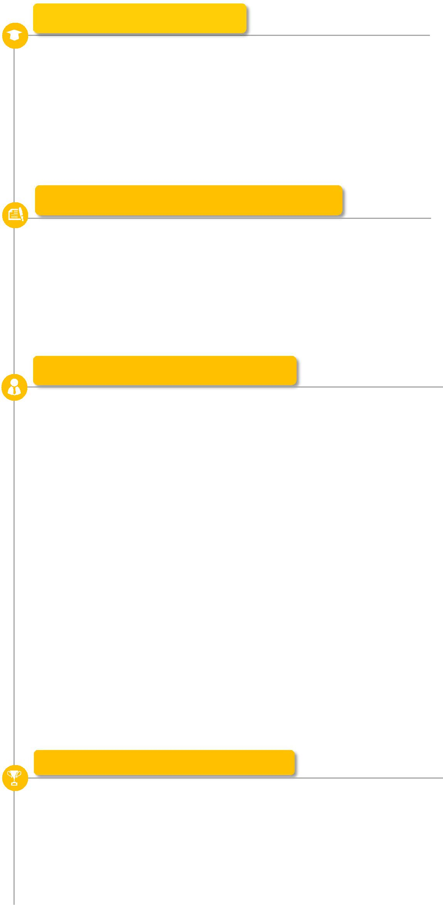

B.Sc. (mathematics With HONS)

ALIGARH MUSLIM UNIVERSITY.

Senior Secondary School,

ST.THOMAS ACADEMYSAHARANPUR UP .

Secondary School,

AVMHSS INTER COLLEGE HARIPUR SAHARANPUR, UP

PROFESSIONAL EXPERIENCE

Online Tutor – India

27 SEP. 2016 TO PRESENT

- Under the supervison of Mr Rachit Kurani.

- Solving the question of Mathematics of higher classes.

- It is learning process.

ABOUT ME

To work hard and achieve my ambitions and organizational objectives in the field of Health, Teaching and expert as Mathematical specialist. To contribute my talents to the well being of the organizations in terms of production, quality and teaching achievements.

  - Fast learner, hardworking and dedication in work.

- Possess excellent interpersonal, communication and organizational skills.
  - Upgrade myself as when required.

  - Excellent interpersonal skills and able to work independently as well as in a team environment with individuals of diverse Backgrounds
  - Ability to identify potential issues and revise current processes to improve the operations.
  - Highly skilled in handlingmultiple taskssimultaneously and work under pressure.
  - Extensive knowledge of detecting fire hazards.

  - Ability to gather and investigate facts to determine cause of hazards.

PROFESSIONAL SKILLS

- Preparing reports and risk assessment

- Knowledge of first aid method and techniques.

- Ability to work on own initiative.

- Hard work and Smart work

- Knowledge of Microsoft packages

- Team work and friendly in nature.

DEVICES TRAINED

1.Gun

2.Lathe Machine

3.Laptop and Computer

4.MOBILE Phone

PERSONAL DETAILS

Date of birth : 09/06/1996

Nationality : Indian

Gender : Male

Martial Status : Single

Languages: English ,

Hindi, Urudu

- Team Work

- Quick Learn

- Easily Adjustable

- Create a good atmosphere
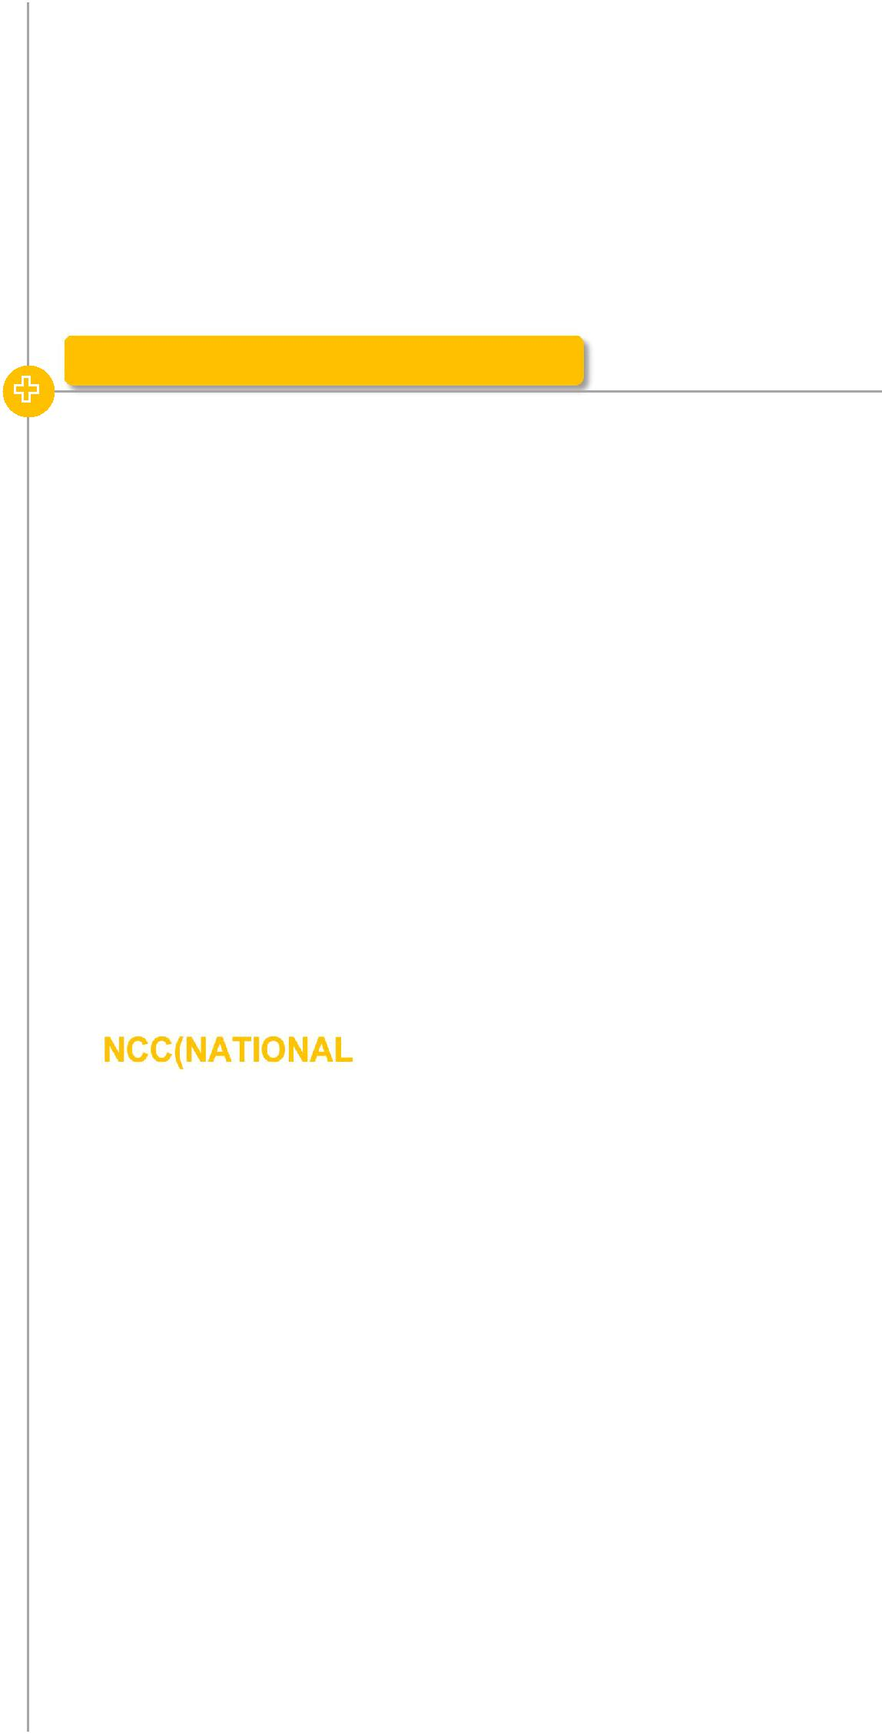

MORE WORKS

NSS(NATIONAL SCHEME SERVICE) / 8/09/2015 - 19/10/2017

  - Worked in 2 days in a week.

  - Visit &ConductingClass-room andTraining for workmen & supervisors.

  - Ensure that everything is correct or not.

- Conduct the management for new Employee and Contractor worker.
  - Daily induction to all new contractor employees.

  - Daily talk/ briefing to all site workmen.

- Conducting General awareness about the programme.

  - Find the Unsafe Conditions, Unsafe Act and Violation of s Rules in the site to initiate action for rectified by Visit.

/ 01/06/2015 - 30/07/2018

NCC training:

Elementary first aid

Daily Management

Parade Management

Discipline Management

Health and Hygiene Management

PLACE :

DATE : FIROJ

