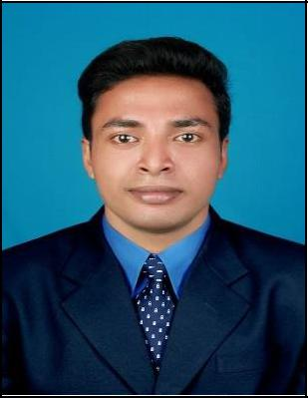

Sanoop

MECHANICAL ENGINEER

sanoop-393426@2freemail.com

Nationality | : | Indian
Visa status | : | Visit visa
Marital Status : |  | Single
Date of Birth | : | 12/04/1993

OBJECTIVE

Seeking a promising career that provide an opportunity to apply and enhance my current skills, acquire new skills and contribute constructively to the organization

LANGUAGES KNOWN

- English

- Malayalam

- Hindi

- Tamil

Curriculum Vitae

WORK EXPERIENCE

- QUALITY CONTROLLER - (4-8-2017 to 11-4-2019)

  - Make sure that the vehicle produced in standard format

  - Ensure that the incoming parts, in house parts, plate and painted parts, Electrical are in conformity with the established quality standards.
  - Exposure in resolving customer field complaints related issues and vehicle engine testing.

- SERVICE ADVISOR - Royal Enfield (1-8-2016 to 3-8-2017)

  - Specialized in meeting client needs in a timely manner while effectively communicating with auto technicians and using Industry-specifics computer programs to track customer activates.
  - Performed customer follow-up contact to ensure customer satisfaction and record customer vehicle service issues in company database and resolved customer complaints and prepared customer invoice

SOFTWARE SKILLS

- Catia

- Auto CAD / Solid Works

- Auto desk Rivet MEP

- Microsoft Excel, Powerpoint

EDUCATION

B.Tech - Mechanical Engineering (2010 – 2014)

SNMIMT Maliyankara, Kerala

Academic project : Bio-Fuel Extraction from Waste

Plastic Material

INDUSTRIAL TRAINING ATTENDED

Kerala Solvent Extractions

