KeySkils

RevenueGeneration

CustomerService

RetailBranchBankingOperations

Equity/CommodityMarketTrading

CASAOperations

Sales&Marketing

MarketResearch

StrategicPlanning

TeamBuilding&Leadership

Abhijeet
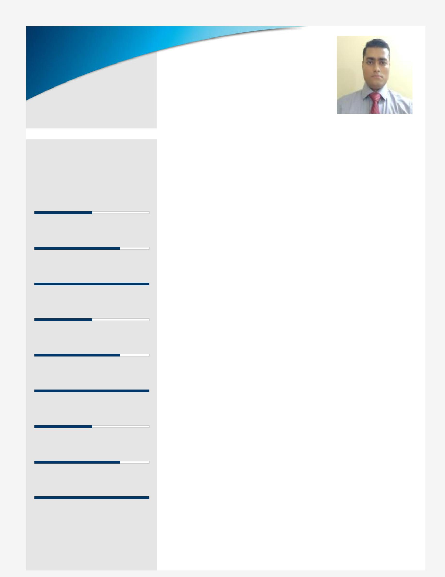
BANKINGOPERATIONS

abhijeet-393435@2freemail.com

RetailBranchBankingwithAMFI(AssociationofMutualFundsofIndia)Certified

professional,skiledinbuildingkeyrelationshipstoenhancecompanygrowth whilemaintainingathoroughunderstandingofleveragingexisting&emerging technologiestodrivebusinessgoals;targetingassignmentsintheBanking& FinanceServicesacrossDubai,BahrainQatar,IndiaandCanada

ProfileSummary

- (Marketing)professionalwithnearly13yearsofexpertisein consistently increasing corporate revenues through new business developmentandmaximizingexistingaccountsfortheBanking&Financial

Servicesindustry

- Experiencedinincreasingsalesrevenues,exceedingtargetedsalesgoals, developing profitable and productive business relationships with key influencersandbuildinganextensiveclientbase

- Professionalexcelencein monitoring variousbanking operationsand maintaininglong-termcustomerrelationshipsthroughtheprovisionofhigh qualityservice;managedsalesintheareasofBG,WorkingCapital,LAP,

CashCredit,BilDiscounting,Assets,Demat,Forex&CreditCards

- Gained expertisein RetailBranch Banking Operations whileensuring effectivemanagementtoaccomplishoveralcorporateobjectives;skiledin monitoring RTGS & NEFT,Cash & Non-cash Foreign Exchange Transactions,ForeignRemitances,ForeignDraftsandTraveler’sCheque

- Competencyinmanagingbranchoperationsandimplementingstrategies towardsenhancingmarketpenetration,businessvolumesandgrowth; increasedtheCASAbookvaluebythreefoldsfrom30milionsto110milions inFY2017-18

- Possessunderstanding ofboth domestic& world marketand other economicfactorsassociatedwithit

- An excelentcommunicatorwith honed interpersonal,team building, negotiation,presentationandanalyticalskils

CareerTimeline

Sharekhan |  | FutureGeneral |  | as
Limitedas |  | LifeInsuranceas |  | BranchSales
Relationship |  | SalesManager |  | Manager
Manager
May’06-Apr’09 | Apr’09-Dec’09 | Dec’09-Dec’10 | Dec’10-Oct’16 | SinceNov’16
 | IndiabulsSecurities |  | as
 | LimitedasSenior
 |  |  | DeputyManager
 | Relationship
 | Manager

WorkExperience

PresentlyworkingsinceJune2019withassales
inDubai,UAE.

SinceNov’16in,IndiaasBranchSalesManager

Dec’10-Oct’16inKolkata,IndiaasDeputyManager

Dec’09-Dec’10withFutureGeneralLifeInsurance,Kolkata,IndiaasSalesManager

Apr’09-Dec’09withIndiabulsSecuritiesLimited,Delhi,IndiaasSeniorRelationshipManager

May’06-Apr’09withSharekhanLimited,Delhi,IndiaasRelationshipManager

KeyResultAreas:

- Spearheadingateamof4BranchSalesExecutiveforachieveingthegivenbranchtarget

- Conductinginternalqualitychecksanddevelopingstrategiesforreducingtheatritionlevelasperthestandard

- Conceptualizingstrategiesrelatedtobankoperationsforthebranch'shugesuccess

- Liaisingwithcustomersandotherfinancialinstitutionanddesigningplansforpromotingproducts&servicesand therebyatractingcustomers

- Takingcustodianshipofdeliverablesentailingwelcomekits,debitcards,chequebooks,instantkitsandlockers

- Supervisingotheroperationswhichincludesonlinestockmanagement,recordinginwardsandoutwardgoing

documents,chequebookrequestprocessingandbookingfixeddeposits

- GeneratingleadsforSavingsAccounts,CurentAccounts,TermDeposit,CreditCardsandInsuranceproducts

- ParticipatinginEquityandCommodityMarketTrading(PortfolioManagement)

- ManagingRTGS&NEFT,CashandNon-cashForeignExchangeTransactions,ForeignRemitances,ForeignDrafts andTraveler’sCheque

- Offeringservicestoexistingcustomersandcontrolingalaspectsofcustomerrelationships

- EnsuringhighqualitystandardsofcustomerexperienceandadheringtotheSLAsandworkprocesses

Highlights:

- Atainedhighestperformanceratingof5inperformanceappraisal(FY2017-18)atBandhanBankwithTop10PAN IndiaRankingunderBSMCategory

- IncreasedtheCASAbookvaluebythreefoldsin2017-18byacquiringsomequalitycustomerswithhugeinflowof freshfunds

Education

- PostGraduateDiplomainBusinessManagement(Marketing)fromNILM,NewDelhi,Indiain2006

- BachelorofCommercefromUniversityofAlahabad,Indiain2003.

Certifications

- AMFI(AssociationofMutualFundsofIndia)Certification

- NSEAcademyCertificationinFinancialMarkets

PersonalDetails

DateofBirth:10thAugust1981|LanguagesKnown:English,HindiandUrdu

Nationality:Indian|MaritalStatus:Maried

IndianDrivingLicense
No.ofDependents:1

