GRISHMA
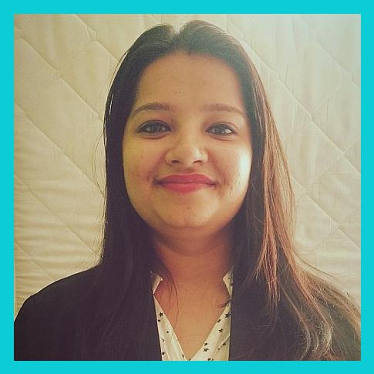

Human Resource Assistant / Administrator

A respectable employee in a corporate sector that gives me the opportunity to learn, innovate and contribute to the growth of the organization.

Dedicated & focused office administrator able to complete multiple tasks simultaneously.

Grishma-393441@2freemail.com

EDUCATION

06.2013 - 05.2015

Nagindas Khandwala College, Mumbai University.

Master of Commerce.

06.2010 - 05.2013

M.J Pancholia College, Mumbai University.

Bachelor of Commerce.

EXPERIENCE

07.2017 - 05.2019

Assistant Professor cum HR generalist

Build strong relationships with students & influencer connected with different colleges.

Fielding Telephone calls,receiving & directing visitors,word processing,creating Spreadsheets & presentation along with filings.

Processing payrolls of faculties, admission enrollment affiliated by university norms.

Guiding lecturers for theory subjects.

Lecturer for under graduates students in course of Bachelor of Management Studies, B.Com (Banking & Insurance), (Financial Markets), (Accounting & Finance) & Bachelor of Mass media. Presentation to large audiences including Principal,Colleagues,Parents & Management.

Worked as an Vibrant program officer in NSS cell for attending seven days residential camp with students in developing area.

Active member for inviting events & job opportunities in collaboration with placement cell.

04.2015 - 06.2017

Administrative assistant

Arranging appointments,Booking meeting rooms & conference facilities.

Data Entry, General office Management such as ordering stationery.

Posting job ads, organizing resumes,scheduling interviews,serving as point of contact for all employees.

Record maintenance for database.

04.2012 - 03.2015

Customer Executive Officer

Engaged in resolving queries and complaints for walk - in customers.

Ensuring regular reports for the team & distributors.

Preparation of various reports of clients for database.

tegic communication with clients over online, mail, & telephone.

SKILLS |  | SOFTWARE SKILLS
Good communication - written and oral skills |  | Microsoft Word
Excellent conceptual and analytical skills
Effective interpersonal skills |  | Microsoft Excel
Problem Solving skills
Willingness to learn skills |  | Microsoft Powerpoint
PERSONALITY |  | HOBBY
Communicative | Punctuality
Creativity | Organized
Responsible | Self Motivated
 |  | Travelling | Music

LANGUAGES

U.S. English

Hindi

Gujarati

Marathi

ACHIEVEMENTS

Awarded as "CASI Community Leader" in the appreciation of services towards the society by the Public Works Department, Maharashtra, India.
Awarded as “Social Action leader” by Indian development Foundation, NGO.

ADDITIONAL INFORMATION

Marital Status - Married

Nationality - Indian

Visa Status - Visit

Visa Expiry - August,2019

I

