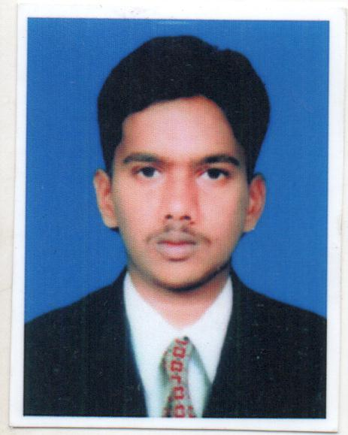  Personal Data:  Date of Birth : 29/10/1991  Sex :Male  Nationality : Indian  Marital Status: Married  Languages Known: English, Tamil., (Read & Write) | ProfessionalObjective:  To obtain a long-term career with an organization which has a strong background that provides good opportunity for enhancement of professional and personal status.  Education:  - DIPLOMA.(MECHANICAL 2008 - 2011)  St. Xavier’s polytechnic college,Seydunganallur, Tuticorin.  Marks obtained:71.0%  - SSLC (2007-2008)  The Muslim Higher Secondary School, Tirunelveli.  Marks obtained : 51.2%  Skill Sets:  - Packages : AutoCAD and MS Office.  - Well versed with the usage of Internet, E-mail.  Field of Interest:  - Metrology machine tool maintenance and testing  - Automobile technology  - Industrial Engineering and Management  Personal Strength:  Effective time management  Quick learner and hard worker  Good Leadership with the Team work
RESUME:
ABDUL Mail ID: abdul-393444@2freemail.com

Working Experience:7 Years
- AsMechanical Supervisor Dubai, UAE
(From21.06.2017 to Present)

Nature of Work:
- Inspect, service and maintain diesel engines
- Disassemble, Repair and Re assemble Engines
- Clean and lubricate component parts.
- Performed Preventive and Scheduled Maintains
- Diesel Engines commissioning and installations
- Troubleshooting of different brand Engines
- Attended training for ELECTRICAL ENGINES &FIRE FIGHTING PUMPS

- As Relationship Advisor in Kodai Cars (P) Ltd,(Dealer of Mahindra &Mahindra) Tirunelveli Tamilnadu,India (From Jan 2016 to Mar 2017)
Nature of Work:
- Handle inbound, telephone, customer relations and retention enquiries
- Resolve any conflicts or issues including price increase queries
- continually review the service offering to ensure that customer requirements/expectations are met, facilitating service changes where necessary
- Ensuring all contracts and relevant paperwork is updated as required\
- Maintain an excellent knowledge of company service offering and the waste management industry as a whole as well as being responsive to changes within the sectors/markets of our customers.

- As Service Advisor in Kodai Cars (P) Ltd, (Dealer of Mahindra &Mahindra) Tirunelveli Tamilnadu,India (From Jan 2013 to Dec 2015)
Nature of Work:
- To Make Inventory of vehicles
- To Prepare estimate of Damaged parts of vehicles
- To Do final inspection after completion of repair works before delivery of vehicles
- Greeting customers and scheduling service appointments
- cataloguing customers concerns and comments
- writing service orders and descriptions of problems and repairs
- translating customers’ repair problems into standard repair terminology
- Explaining repairs to customers

- As MechanicalSupervisorinKodai Cars (P) Ltd,(Dealer of Mahindra &Mahindra) Tirunelveli Tamilnadu,India(From Dec 2011 to Dec 2012)
Nature of Work:

- To Assess Brooked and repaired parts of vehicles
- To Control the Mechanics and Tinkers in Body shop portion
- To Alert the job for Technician
- To Control the Mechanics service portion
- To do final inspection after completion of repair works before delivery of Vehicles.
- To led and Conduct the morning meeting everyday with all the Mechanic and Technicians.

Project Developed:

MAIN PROJECT:

DESIGN AND FABRICATION OF HYDRAULIC VISE

In plant Training:

At Hero Honda (05th may to 15th may 2010)

Hobbies:
- Browsing
- Playing Cricket

Declaration

I here by declare that all the information mentioned above is true to the best of my knowledge.

Place: Dubai, UAE Date: ABDUL

