Skill Set

Project Management

Site Management

Installation of ISO 9001 Quality System

Liaison &
Coordination

Contract
Management

Resource
Management

Team Building & Leadership

Civil Engineering

Budget Management
& Cost Controls

IT Skills

Primavera P6 (Project Management), Primavera P3 (ver. 3.1), Microsoft Project MS Office Applications and other graphics software

VENU

Corporate Planning | Project Planning

A versatile, high-energy professional with the merit of executing projects of large magnitude within strict time schedule, cost & quality

Industry Preference: Construction

Email: venu-393460@2freemail.com

Profile Summary

A competent professional with nearly 30 years of experience in Site Engineering, Corporate Planning, Project Planning & Construction Project Management
A strategic planner with expertise in managing day-to-day operational aspects of projects and project scope by effectively applying methodologies that enforce project standards and by minimizing exposure and risks on projects
Expertise in planning & spearheading construction projects involving Contract Administration, Resource Planning with a flair for adopting modern construction methodologies in compliance with quality and H S E policies of company.
Directed, controlled and managed various aspects of the project including in-house engineering, procurement, construction, interfaces, administration functions and all external work undertaken by contractors and consultants throughout the design, supply and construction phases of the projects
Possess skills in preparing cost / time / resource budgeting of multi-discipline & multi-location teams
Excellent relationship management, analytical and negotiation skills with expertise in swiftly ramping up projects in coordination with clients, contractors, vendors and consultants

Education

M.Tech. (Structure) from Jawaharlal Nehru Technological University, Hyderabad, India in 1996
BE (Civil) from Jawaharlal Nehru Technological University, Hyderabad, India in 1986

Career Timeline
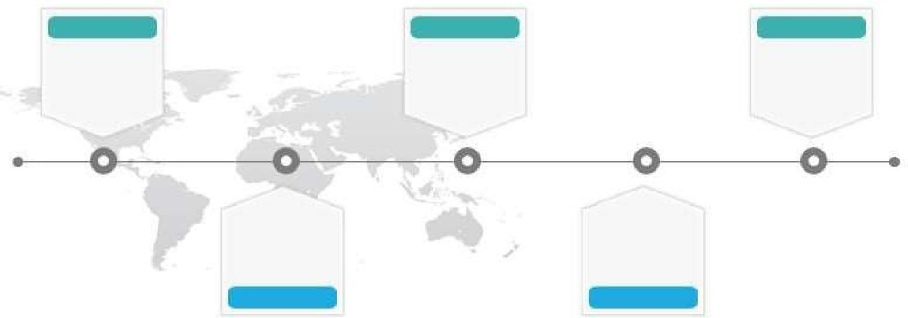

1987-1988 | 1989-1996 | 1999 till date
SVEC | Babuji Estates
Constructions,
India as Site | Pvt. Ltd., | Planning
Engineer | India | Manager

Kodai
Engineering,
as
India as Site
Planner / Sector
Engineer
Engineer
1987-1989
1997-1999

Work Experience

Since Mar'99 as Dy Planning Manager

Growth Path: Planning Engineer / Sr. Planning Engineer / Asst. Planning Manager / Dy. Planning Manager

Key Result Areas:

Spearheading projects involving estimation of the required manpower months, preparation of bills, manpower mobilization, equipment mobilization, cash management, floating enquiries to sub- contractor and so on Anchoring on-site construction activities to ensure completion of project within the time & cost parameters and effective resource utilization to maximize the output
Administering all construction activities including providing technical inputs for methodologies of construction & coordination with site management
Following the technical specifications & scope and deliverables; reviewing cost estimates & reviewing contractor's change order proposals & submittals
Supervising and monitoring the performance level of the service staff for ensuring superior customer service and accomplishment of service targets
Inspecting field sites to observe & evaluate facilities & structures and to collect field survey data & measurements; identifying the risk in execution with respect to HSE
Coordinating with consultants & clients for solving construction problems and to deliver the project according to the specifications while adhering to the safety and environmental requirements.
Procuring project material, coordination and follow-up with vendors for the various projects Reporting the weekly and monthly projects status report to higher management

Highlights:

Completed a high net-worth project worth AED 1.4 Billion involving an esteemed set of clientele including Mubadala Initiated the timely execution of Al Sayegh Tower , Rotana Hotel Extension and Al Towayya Ambulatory Health care center projects within budget; implemented cost control strategies such as ARMS reports as well as effective estimates for site infrastructure
Successfully delivered pre-qualifications and Request for Proposals (RFP’s) for various projects includes Al Ain Airport (AED 1.4 Billion) , Al Ain Hospital (AED 2.5 Billion) and Shk. Khalifa Medical City (SKMC) AED 3.50 Billion Executed the onsite project management functions for Al Ain Airport Hangers including support facilities and infrastructure and various projects , especially structural works and high end interiors

Previous Experience

Jan’97 – Feb’99 with Sheth Consultancy Service, Mumbai as Planner / Sector Engineer Dec’89 – Dec’96 with Babuji Estates Pvt. Ltd., Hyderabad, India as Project Engineer Oct’88 – Nov’89 with Kodai Engineering, Hyderabad, India as Site Engineer
Oct’87 – Sep’88 with SVEC Constructions, Hyderabad, India as Site Engineer

Project

At Al-Faraá Gen. Cont. Co. LLC, UAE

Project Title: 5 Star Hotel and Hotel

Project Net Worth: AED 201 Million

Designation: Dy. Planning Manager

Year: 2018-2019

Apartment, Dubai

Project Title:

Project Net Worth:

Designation:
Year:

Al Ain Airport Hangers with supports facilities including infrastructure woks, Al Ain

AED1.40 Billion
Dy. Planning Manager

2016-2018

Project Title:

Project Net Worth:

Designation:

Year:

Al Towayya Ambulatory Healthcare Center, Al Ain

AED 45.60 Million
Dy. Planning Manager

2014-2016

Project Title:

Project Net Worth:

Designation:

Year:

Rotana Hotel Extension, Al Ain

AED 100 Million
Dy. Planning Manager

2013-2014

Project Title:

Designation:

Corporate Planning for Various Projects

Dy. Planning Manager

Year:

2009-2013

Project Title:

Project Net Worth:

Designation:
Year:

Al Sayegh Tower, Abu Dhabi, UAE

AED 185 Million
Sr. Planning Engineer
2007-2009

Project Title:

Project Net Worth:

Designation:

Year:

Celebration Hall, Al Ain, UAE

AED 40 Million

Sr. Planning Engineer

2005-2007

Project Title:

Project Net Worth:

Designation:
Year:

VIP Suits at Al Mafraq Hospital, Abu Dhabi, UAE

AED 80 Million
Planning Engineer
2003-2005

Project Title:

Project Net Worth:

Designation:

Al Mada Residential Complex, Al Ain, UAE

AED 75 Million
Planning Engineer

Year:

2001-2003

Project Title:
Project Net Worth:

Designation:

50 Villas for Shk. Suroor, Al Ain, UAE

AED 50 Million
Planning Engineer

Year:

1999-2001

Trainings

Project Progress & Delay Calculation using Primavera Level 3, by Society of Engineers, UAE
Internal Auditor Training Course on The Elements of ISO 9001, Audit Planning, Preparation & Reporting from International Certifications Ltd., New Zealand
Internal Auditor Training Course from ASTECH, UAE

Personal Details
Date of Birth: 3rd March 1961
Languages Known: English , Hindi and Telugu
Nationality: Indian
Marital Status: Married
Visa Status: Residence Visa; valid till 9th Feb 2021
Driving License: UAE driving License

No. of Dependents: 3

