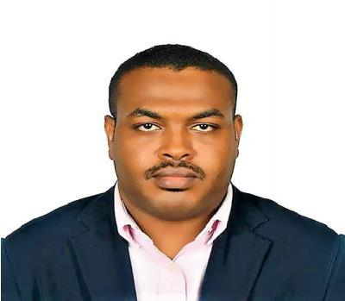

AREAS OF EXPERTISE

Structural design

Infrastructure projects

Large scale commercial buildings

Public sector buildings

Site Inspections

Project management

COURSES & WORKSHOPS

AutoCAD

Autodesk Revit Structure

Primavera

ETABS

Elhibir
Civil & Structural Engineer / Researcher

Elhibir-393474@2freemail.com | Dubai, United Arab Emirates

Experience: 6 Years
Highest Qualification: Master Degree in Structural Engineering and Constructions
Certification: DM & FM Certified
Nationality: Sudanese
Languages: Native Arabic & Fluency in English
Driving License: Valid UAE Driving License

SUMMARY

Civil & Structural Engineer with a Master in Structural Engineering and Constructions. I have about 6 years of experience in research and construction industry, mostly worked in High rise building and infrastructure projects. Well familiar with Euro Codes and British Standards and relevant structural design software such as Revit, Etabs, SAP 2000, Esteem, Orion and AutoCAD with high ability to learn new structural design software.

Alongside the above, I have Published 2 papers on Lightweight Concrete and Self-curing Concrete, Currently, I am working on publishing my 3rd paper regarding durability performance of self-curing concrete.

Academic Qualifications

Master of Structural Engineering and Constructions

Universiti Putra Malaysia (UPM), Selangor, Malaysia
First Class

2015 – 2017

Bachelor Degree in Civil Engineering (Hons)

Infrastructure University Kuala Lumpur, Selangor, Malaysia

Second Class Upper

2012 – 2014

Diploma in Civil Engineering

Sudan University of Science and Technology, Khartoum, Sudan Second Class Upper
2006 – 2009

CAREER HISTORY

Dubai, UAE

Project Engineer Dec. 2017 – Present.

Field Engineering with emphasis of inspection, testing, and implementation in the field structural, civil, architectural. Ensuring good quality of workmanship has been conceded in accordance with Project Specifications, Codes and Standards requirements and other related applicable to contract documents. Possessed adequate experience in implementing and executing task required in promoting services that will correlate in obtaining common company objectives of providing quality output in all aspects of work.

Selangor, Malaysia
Researcher Feb. 2015 – Mar. 2017

Structural engineering and concrete technology researcher focused on the mechanical properties and durability performance of fiber reinforce concrete and self-curing concrete.

Binastra Ablebuild Sdn. Bhd. - Selangor, Malaysia

Project Engineer Jul. 2014 – Jan. 2015

Responsible for ensuring that all activity meets both internal company standards and external regulatory requirements with respect to Health, Safety and the Environment to ensure the Company's obligations and policies in these areas are fully complied with.

Elmrafe for Roads & Bridges - Khartoum, Sudan

Project Engineer Dec. 2010 – Feb. 2012

- Started out as site engineer responsible for documents and assisting senior engineers and promoted to project engineer after two projects.

- Supervision to carry out works as per standard to maintain quality in work Approved materials

KEY SKILLS AND COMPETENCIES

Civil Engineering attributes

- Superb critical thinking skills and the ability to evaluate designs, plans and projects.
- A good understanding of reinforced concrete structures design.
- Well familiar with Euro Codes and British Standards.

- Familiar with relevant civil engineering design software eg Esteem, Orion and AutoCAD with a high ability to learn new structural design software.

- Knowledge of construction methods and construction sequences in civil structural constructions.
- Experience in preparing Bill of Quantities for structures.
- Promoting the highest standards of safety onsite at all times.
- Assessing the environmental impact and risks connected to projects.

Professional attributes

- Able to check the work of others & supervise less experienced.
- Pricing, quoting and resourcing work within delegated authority levels.
- Writing accurate technical reports.

- Computer literate and conversant with MS Office suite and relevant engineering software packages.
- Capable of defining and leading assignments.
- Always willing to help other team members with workloads.
- Supporting any procurement processes.

