CURRICULUM VITAE (CV)
Personal Information
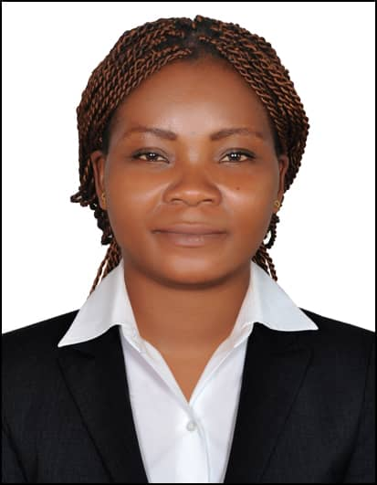
Name: DJENDA
Address: UNITED ARAB EMIRATE (DUBAI)
Nationality: CAMEROONIAN
Date of birth: 10/04/1989
Gender: Female
Marital Status: SINGLE
Visa type: VISIT VISA
Email: djenda-393481@2freemail.com
POSITION: ENGLISH TEACHER
Objective
A bilingual(English & French) Teacher need to obtain a position as a primary school English Language teacher that will utilize my dedication to student’s educational needs and development. To encourage creativity and higher-order thinking in a way that increases student performance.
Academic Qualifications
2012 : AdvancedLevel General Certificate of Education in Yaounde (Cameroon).
2012-2013 : university of Yaounde 2,Soa specializing in English Language from Cameron's state University:
2014 : AMERICAN LANGUAGE CENTRE .
2015 :Diploma in Yaounde specializing in teaching in the Government Teacher's Training College . Teacher Grade One Certificate Examination CAPIEMP Cameroon
Professional Experiences
2015 - 2017 : English Teacher in Marie-Albert private primary school biteng-yaounde
2017 – 2018 :Maths Teacher in Primary School
2018 – 2019 : French Teacher in Primary School
Seminars
November 4th 2016 before the celebration of international teachers day, took part in a workshop organized by the Regional Delegate of Secondary Education with theme "techniques used to make learners read fluently"
February 2017 and February 2018- Attended the regional pedagogic seminar organized by the Regional Pedagogic Inspector for the Southwest Region where I did an exposé during the workshop session titled: “The Importance Of time and Classroom Management”
March 2019- Attended a three (3) days In Service Training Program (ISTP) which is a pedagogic seminar organized by the Presbyterian Education Authority for the Center regionunder the theme “Competence based approach, a reality to effective teaching methods and the techniques used to evaluate learners in accordance with the new curriculum”
Professional skills
Can develop teaching techniques that will adapt to the needs of all groups of students to enhance performance
Can fish out individual weakness of students and can adopt appropriate methods that can adapt their special needs
Can work under pressure both as an individual and as a team
Have a great professional relationship with students, colleagues and administration alike
Can easily take and adapt to new challenges
Very duty conscious
Languages
English: Can speak and write perfectly
French: Can speak perfectly and write perfectly
Other Skills
Can perfectly use Microsoft word perfectly, Excel averagely and the internet
Hobbies
Reading
Listening to music
Travel to new places
Like to socialize
Cooking
Like to watch and play football.
Children Care
References
Will be provided on demand to satisfy the purpose for which it is intended.
DECLARATION
I hereby declare that the above information is true. All the information provided has not been overrated neither has it been done with the intension of deceiving the user.

