RESUME

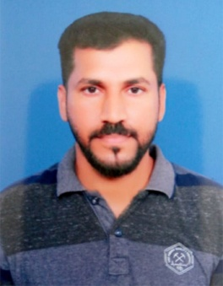

RASHID
Sharjah, UAE
Rashid-393484@2freemail.com

My profile summary:

- 9 years experience in driving in UAE with well knowledge of locations
- Speak fluently English, Arabic & Hindi (Keralite)
- Able to communicate in English in writing
- Able to work in Windows 10, Ms Office applications + web browsing
- Experienced in Store Keeper/ Messenger jobs
- Matriculation passed
- Fast learner, ready to work anywhere in UAE
- On visit Visa up Oct 2019

OBJECTIVE:

Seeking a challenging position to meet my competencies, capabilities and skills.

WORK EXPERIENCE:

Store Keeper cum Collection Executive –Sharjah
(Products & Services : Crushing, Screening, Washing Plants and Equipment etc)

10 years of experience (From 2008 to February 2019)

Duties And Responsibilities – Store Keeper:-

- Maintain Receipts, records and withdrawal of stock room.
- Receive, unload and shelve supplies.
- Perform other stock related duties including returning, packing and labeling.
- Ensure adequate record keeping and manage all documentation.
- Maintain proper stock level.

Duties And Responsibilities – Collection Executive:-

- Coordinate the handling of freight, movement of equipment etc.
- Cheque collection, Bank Deposits, collection of documents.
- PRO works assigned by HR.

LANGUAGE KNOWN:

- Excellent communication skill in Arabic, Hindi, English, Malayalam etc.

EDUCATIONAL QUALIFICATION:

- Matriculation – Year of Pass 1995

COMPUTER SKILLS:

- Windows, Internet & MS Office – Excel & Word

UAE DRIVING LICENSE DETAILS:

- Issue Date : 27-12-2010
- Expiry Date : 28-12-2020

PERSONAL INFORMATIONS:

- Date of Birth : 02-04-1980
- Nationality : Indian
- Religion : Islam
- Marital Status : Married
- Current visa status : Visit visa- till 18th Oct 2019

Declaration

I hereby declare that the information furnished above is true to the best of my knowledge.

Place : Signature

Date : RASHID

