AKSHAY
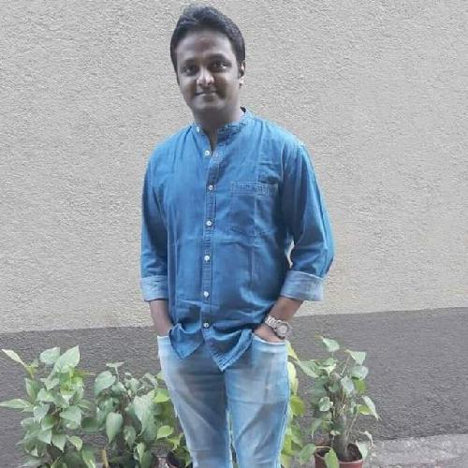

Akshay-393503@2freemail.com

Personal Details

Date of Birth | : | 01/12/1987
Marital Status : |  | Married
Nationality | : | Indian

Objective

Enthusiastic and highly motivated with more than 12 years of work experience, ready and eager to apply theoretical knowledge and practical experience. Possesses a strong work ethic and desire to further develop knowledge and skills. Effectively manages multiple tasks at a time with competing deadline.

IT Skills

Excel, Word, Power Point, Tally, SAP, Lotus, Outlook, Helios, Concur, AutoCAD 2D etc.

Education

2018 | IIBMS
 | BBA (Administration)
2006 | DVM College, Maharashtra
 | HSC
2003 | St. Anthony's High School
 | SSC

 |  | Experience
August 2015 - July | Administration Incharge
2019 | - Handling Repair & Maintenance work i.e. Electrical, Carpentery, Plumbing
 | and Civil.
 | - Taking care of Safety items like Smoke/Heat Detector/Fire Extinguisher.
 | - Maintaining in house plants.
 | - Taking care of all Housekeeping work.
 | - Handling Space Management.
 | - Handling Key Management.
 | - Helping hand for Procurement Team.
 | - Preparing Budget related to an Administration.
 | - Taking update on Oﬃce Stationary consumption and inventory.
 | - Taking update on Housekeeping material consumption and inventory.
 | - Handling Security Guard, Gate Pass Book, Inward, Outward, Lost and Found Register's
 | - Submission of Invoices and payment follow-up.
 | - Organizing events like National Days, Navratri/Dusshera, Diwali, Christmas etc.
 | - Arranging Pest control of oﬃce area.
 | - Looking after oﬃce boys and their requirements.
February 2014 - | MIS Executive

August 2015 May 11 - February 2014

- Creating Purchase Request in Helios system.

- Follow Up for Purchase Order from Purchase team.

-Working in SAP (MIGO / ME2L / ML81N / FBL1N) for doing GR/SR.

- Maintaining data of PR, GRN & SRN in excel sheet.

- Maintaining files of Invoices, Credit Card & Expenses statement which are submitted to

S2P team.

- Handling petty cash and utility, purchase and travels credit cards.

- Submitting petty cash invoice in Concur system for reimbursement.

- Submitting purchase and utility card statement along with invoice to S2P team and

making sure payment are done before due date.

- Follow Up from Genpact Team for Vendors payment.

- New mobile phone connection.

- Preparing Budget sheet.

- Printing of Visiting Card.

- Helping dispatch team for Inward & Outward courier when required.

- Activation & deactivation of Reliance Data cards.

- Providing monthly provision to Finance team.

- Generating MIS Reports Monthly.

- Stationary/ Housekeeping Management/ Stock.

- Managing the Helpdesk in absence of Operator.

Huntsman Advanced Material Pvt. Ltd. (IKYA)

Administration Executive

- Managing various vendors their AMC's.

- Handling car booking on hire/rental basis.

February 2009 - May 2011

- Handling various teams like housekeeping, pantry, oﬃce boy and security guards.

- Maintaining attendance of all employees and punching machines.

- Coordinating with vendors for electrical, carpentry, plumbing and A/c servicing work.

- Make sure pest control is done from time to time.

- Maintaining tea & coffee vending machine and stocks.

- Handling PF & ESIC challans of contractors.

- Making arrangement of flowers & greetings for birthdays, anniversaries, newborn and

condolences.

- Printing of visiting cards, letter heads, certificates etc.

- Looking after stationery requirement.

- Handling Petty Cash.

- Arrangement of event or celebrations which is conducted in Oﬃce premises.

- From July 2012 started working in SAP in various platforms i.e. MIGO & ML81N to

support Supply Chain.

- New mobile phone connection.

- Arrange conference call.

Vipul Facility Management Pvt. Ltd.

Facility Executive

- Attending calls on various complaints & request, forwarding the same to different

discipline i.e.; housekeeping supervisor, technician, and oﬃce boy. And taking follow-up

for the same and get it done.

- Updating Daily Facility Report.

- Updating daily attendance of all the staff.

- Keeping track on Water Tanker & Drinking water consumption on monthly basis.

- Updating track & distribution on Tata Photon to the employee as per the instruction.

 | - Updating track on mobile bills of Vodafone & TTML which belong to Tata Employee.
 | - Look after vendor’s billing document.
 | - Cross checking of Log Book & all Checklists of Housekeeping Supervisor.
 | - Supervising housekeeping, oﬃce boys & pantry boys’ team.
 | Ebiz.com Pvt. Ltd.
May 2007 - | Associated
February 2009 | - Have created group of 1000 associate by promoting company's product.
 | ICICI Prudential Life Insurance
March 2006 - May | HR Executive Assistant.
2007 | - Updating tracker of day to day new joined employee.
 | - Arrange training for new joined employee.
 | - Provide facility for new joined employee like workstation, stationery, phone, employee
 | card, visiting cards, joining formalities etc.
 | - Maintaining stock & track of R&R.
 | Scribe Financial Service
April 2004 - October | Data Entry Operator
2005 | - Handling Petty Cash.
 | - visit to client’s residence to collect day to day bills for Accounts purpose.
 | - Taking care of oﬃce premises.
 | - Worked in Tally 4.5
 |  | Skills

- 9 years of experience in Facility Management. * Expert in Space Management - Team work - Taking Good decisions and problem solving

Additional Information

- Was part of taking handover from CBRE and setting Vipul Facility in Tata Communication for Facility Management Services.
- Payed Major role in shifting of 300 employee from 1 location to other location in Huntsman.

- Have found a space and doing full setup of oﬃce cum warehouse in Parekh

Language

- Read : English, Hindi, Marathi - Write : English, Hindi, Marathi - Speak : Gujrathi, English, Hindi, Marathi

AKSHAY

