ALI

ELECTRICAL ENGINEER

PERSONAL INFORMATION

Name:
Date of Birth:
E-Mail:
Visa Status:

Ali
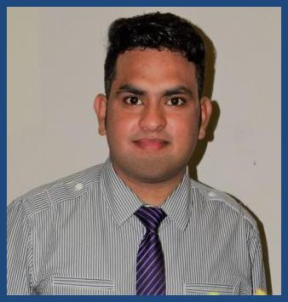
16-03-1992

Ali-393513@2freemail.com
Visit Visa

PROFESSIONAL PROFILE

Seeking an entry level job position in a reputed engineering firm in order to build a long term career by investing the best of my technical knowledge & educational qualifications and to serve the organization with an outstanding output.

EDUCATION

2014 – 2018 | BS Electrical Engineering Technology
 | University of Wah, Quaid Avenue, Wah Cantt.
2013 – 2010 | D.A.E Diploma of Associate Engineer in Telecommunication
 | Wah Swedish Institute of Technology, G.t Road, Wah Cantt.
1997 – 2010 | Matriculation in Science
 | F.G Boys Public High School, Wah Cantt.
PROFESSIONAL EXPERIENCE
July 2018 - Dec 2018 | Industrial Trainee

- Worked in Control Room, Equipment Maintenance Shop, Protection and Installation Department, Relays Room, Battery Room (Dc Power Bank).

- During Shutdowns Replacement of damaged Insulators(Line insulators, Post insulators, Disc type insulators etc.) Replacement of damaged Isolators(Line isolators, Busbar isolators, Circuit breaker isolators etc.)
- Thermo Vision Inspection of hotspot by using thermo vision camera.

- Circuit Breakers make and brake timing test, SF6 gas level check, spring stiffness check, Annual testing of each equipment installed on grid station including Auto and Power Transformers.
- Load Management while issuing P.T.W (permission to work).

Mar 2018 - June 2018 Industrial Trainee
- Worked on Electrical furnace using for melting of brass.
- Worked in Equipment Maintenance workshop.
- Worked on Power factor Improvement system & DC motors drive.

Oct 2017 - Jan 2018

Intern

• During Internship period visited following shops/departments,

SAA Fy, Services, MAA Fy, Power House.
• All Departments are in Pakistan Ordnance Factories the mall Wah Cantt
and doing team work to produce high Standard and reliable armed force weapons
and power house is thermal power plant using high pressure steam to produce
Electrical power to feed P.O.F factories, Employees Residence, Hospital and
others projects.

FINAL YEAR PROJECT IN ENGINEERING

7th – 8th semester Android Based Home Appliances Control via Bluetooth Module

- This project one of the important Arduino projects. Arduino based home automation Using Bluetooth project help the user to control any electronic device using device Control app on their Android smartphone. The android app sends commands to the Controller-Arduino, through wireless communication, namely, Bluetooth. The arduino Is connected to the main PCB which has four relays. These relays can be connected to Different electronic devices e.g fan,T.v,Light & Door bell. User control devices through Android mobile app by pressing ON/OFF button displaying on screen.
SKILLS

- Operating system windows7,8 9 & 10, Microsoft office, Matlab, C, C++, etc.
- Communicative Skills
- Languages i.e., English,Urdu

INTERESTS

- Maintenance of Machines, Equipments
- Troubleshooting of Systems, Machines and equipments
- To study working principles of Machines.

REFERENCES

- Available upon request.

